Name: _________________________________ Chapter 9 Solving Quadratics Review
Solving Quadratics
- Solve for all roots in the following equations:
  - $3x²-2x=16$

  - $3x²-27=0$

- If the zeros of the function are $x=-2$ and $x=7$
  - Write the factors of the function.

  - Write the function in standard form.

- Graph each equation below and determine how many real solutions each one has. Explain how you know.
  - $y=x²-4x+2$ b. $y=-x^{2}+2x-3$ c. $y=4x²+4x+1$

- Solve for x and determine if the solution(s) are rational or irrational. Justify your answer.
$${\left(x-2\right)}^{2}=11$$

Systems of Equations
- Graph $h\left(x\right)=\frac{1}{2}\left|x\right|$ and $j\left(x\right)=-x^{2}+3$ on the grid below. Does $h\left(-4\right)=j(-4)$? Use your graph to explain your answer.

- A company is considering building a manufacturing plant. They determine the weekly production cost at site A to be $A\left(x\right)={2x}^{2}$ while the production cost at site B is $B\left(x\right)=4x+6$, where $x$ represents the number of products, in hundreds, and $A(x)$ and $B(x)$ are the production costs, in hundreds of dollars.
Graph the production cost functions on the set of axes below and label them Site A and Site B.
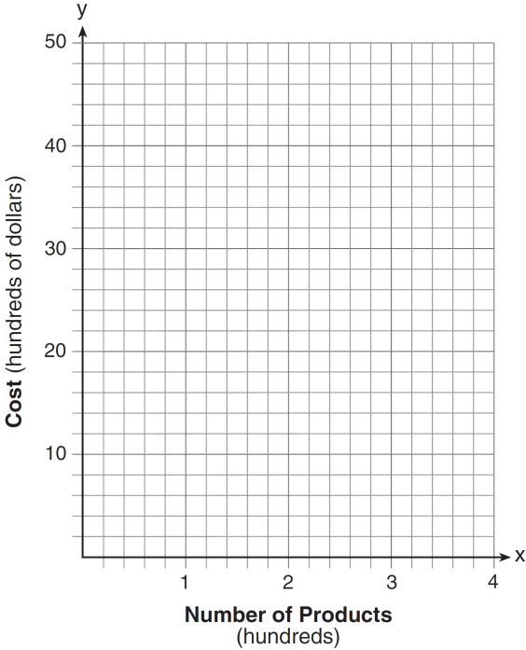

State the positive value(s) of $x$ for which the production costs at the two sites are equal. Explain how your determined your answer.

Review
- When you look at a graph, how do you know where the solutions are? (Are there specific x or y values?)

- The function $f\left(x\right)={-5x}^{2}+80$ represents the height, $f(x)$, in feet of an object from the ground at $x$ seconds after it is dropped. Determine a realistic domain for the function.

- Write the following function in vertex form by completing the square. $y=-x^{2}+6x+2$

- Factor the following quadratic expression completely. $x^{4}-5x^{2}+4$

- The table below shows the average diameter of a pupil in a person’s eye as he or she grows older.
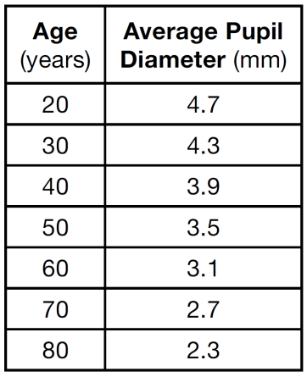
What is the average rate of change, in millimeters per year, of a person’s pupil diameter from age 20 to age 80?

- Solve the equation below for x in terms of a. $4\left(ax+3\right)-3ax=25+3a$

