Name: Period: Graphing Systems of Inequalities Recap!

- $y>-2x+5$
$y≤x-3$

- $y≥-1$
$$5x+3y>-18$$

- $x-2y<-16$
$$x+y≥5$$

- Sarahi knits scarves and sweaters to sell. Scarves take 2 hours to knit and sweaters take 10 hours. Mary would like to spend no more than 40 hours per week knitting and knit at least 5 items per week.
  - Write and graph a system of linear inequalities:

  - State one possible solution:

- Cairo babysits for $x$ hours a week after school at a job that pays $\$4$ an hour. She has accepted a job that pays $\$8$ an hour as a library assistant working $y$ hours a week. She will work both jobs. She is able to work no more than 15 hours a week, due to school commitments. Edith wants to earn at least $\$80$ a week, working a combination of both jobs.

Write a system of inequalities that can be used to represent the situation. Graph them on the set of axes below.
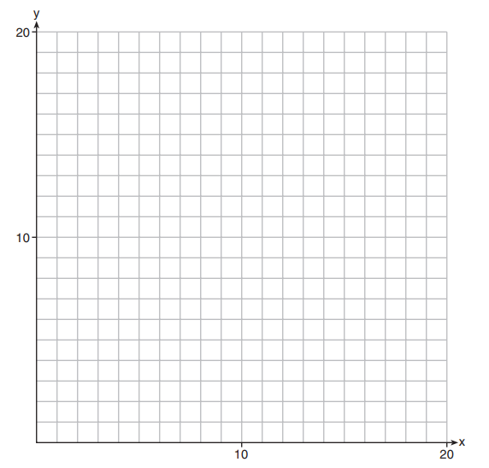

Determine and state one combination of hours that will allow Cairo to earn at least $\$80$ per week while working $no more than$ 15 hours.

