Name: Period: Job 10 Arithmetic Sequences

Part 1: Textbook
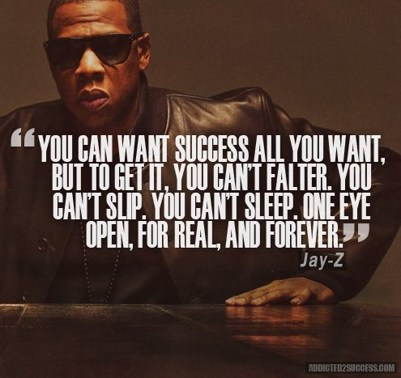
Textbook Lesson 3-4 Pages 116-117: 17, 19, 25, 27, 43, 47

Part 2: Algebra Regents Questions –
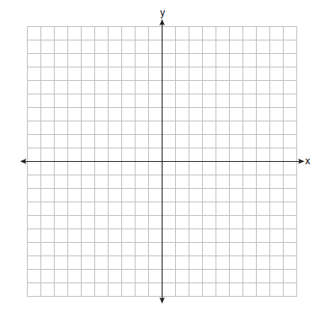
1. Solve for $y$ and graph:$-x-2y=8$

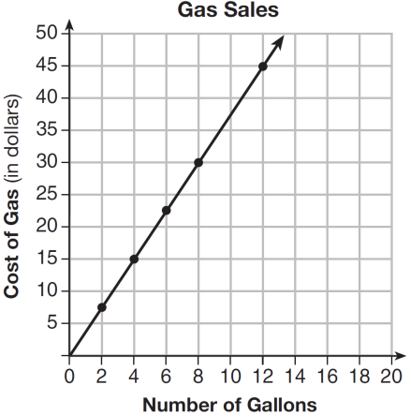
2. The graph below was created by an employee at a gas station.

Which statement can be justified by using the graph?
(1) If 10 gallons of gas was purchased, $35 was paid.
(2) For every gallon of gas purchased, $3.75 was paid.
(3) For every 2 gallons of gas purchased, $5.00 was paid.
(4) If zero gallons of gas were purchased, zero miles were driven.

3. If $A=3x^{2}+5x-6$ and $B=-2x^{2}-6x+7$, then $A-B$ equals
(1) $-5x^{2}-11x+13$ (3) $-5x^{2}-x+1$
(2) $5x^{2}+11x-13$ (4) $5x^{2}-x+1$

4. The formula for the volume of a cone is $V=\frac{1}{3}πr^{2}h$. The radius $r$ of the cone may be expressed as
(1) $\sqrt{\frac{3V}{πh}}$ (3) $3\sqrt{\frac{V}{πh}}$
(2) $\sqrt{\frac{V}{3πh}}$ (4) $\frac{1}{3}\sqrt{\frac{V}{πh}}$

5. Solve the inequality below to determine and state the smallest possible value for x in the solution set.
$$3\left(x+3\right)≤5x-3$$
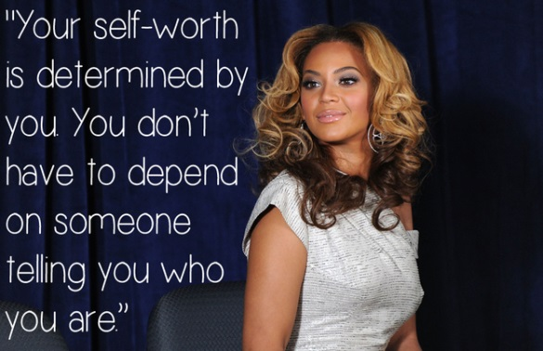

6. A function is shown in the table below.
x | f(x)
–4 | 2
–1 | –4
0 | –2
3 | 16

If included in the table, which ordered pair, $(-4,1)$ or $(1,-4)$, would result in a relation that is no longer a function? Explain your answer.

7. If $f\left(x\right)=\frac{\sqrt{2x+3}}{6x-5}$, then $f\left(\frac{1}{2}\right)=$
(1) $1$ (3) $-1$
(2) $-2$ (4) $-\frac{13}{3}$

