Name Job 11 Scatterplots / Correlation
Part 1: Textbook
Section 3-5 Page 123: 6, 7, 12, 15, 16, Find the line of best fit for 20 and 21

Part 2: Algebra Regents Questions –

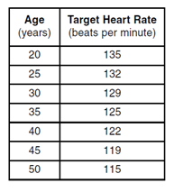
- Use the chart below to answer questions below.

What is the average rate of change to the nearest hundredth of a person’s heart rate from age 20 to 50?

State the value of the linear correlation coefficient, rounded to the nearest thousandth, between a person’s age, in years, and that person’s target heart rate, in beats per minute?

- The graph below represents Patrick jogging within a 20 minute jog around the track.

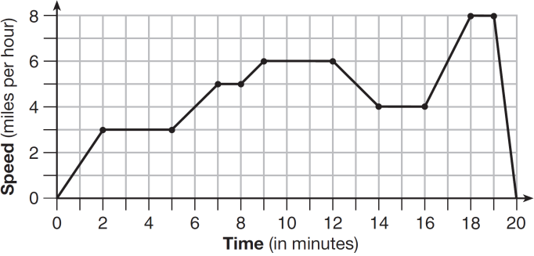

Which statement best describes what Patrick was doing during the 2-5 minute interval of his jog?

(1) Standing still (2) Increasing his speed (3) Decreasing his speed (4) Jogging at a constant rate

- Given the graph of the line represented by the equation $f\left(x\right)=-2x+b$, if $b$ is increased by 8
units, the graph of the new line would be shifted 8 units in which direction?

- The list represents first three terms of a sequence. 12, 16, 18, 22, …Assuming the pattern continues, which formula determines the nth term?

(1) $a_{n}=4n+12$ (2) $a_{n}=4n+4$ (3) $a_{n}=4n+8$ (4) $a_{n}=4n+2$

- For the set of ordered pairs shown {(8,8), (-5,1), (-7,6), (2,1), (8,4), (3,9), (4,-7)}

a) What is the domain? b) What is the range? c) Is it a function? Explain.

- The data in the table below shows the number of hours Ariona studies and the grades she gets in math

Hours | 1 | 2 | 3 | 4 | 5
Grades | 32 | 44 | 51 | 66 | 94

What is the equation of the line of best fit for the data? Round to the nearest whole number.

What is the correlation coefficient to the nearest hundredth?

Based on the correlation coefficient, $r$, how well does the line of best fit describe the data set? Explain.

7. Let f be a function such that $f\left(x\right)=2x+4$ is defined on the domain $2≤x≤8$. The range of this function is
(1) $0≤y≤8$ (3) $8≤y≤20$ (2) $4≤y<20$ (4) $-∞<y<∞$

- The function f has a domain of $\{-2, 3, 6, -10\}$ and a range of $\{1, 2, 3\}$. Could $f$ be represented by $\{\left(-2, 2\right), \left(3, 3\right), \left(-10, 1\right), \left(6, 2\right)\}$? Justify your answer.

- Help Anthony draw the graph of the equation $–2x+3y=6$

Is the point $(3,2)$ a solution to the equation? Explain your answer based on the graph drawn.

