Name: Period: Job 12 Solving Systems By Graphing

Part 1: Textbook
Textbook Lesson 4-1 Pages 148-149: 13, 15, 16, 17, 18, 19

Part 2: Algebra Regents Questions –

1. Erica, the manager at Stellarbeans, collected data on the daily high temperature and revenue from coffee sales. Data from nine days this past fall are shown in the table below.
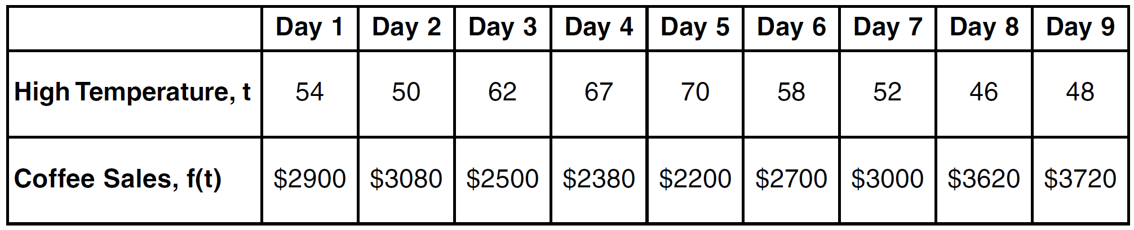

State the linear regression function, $f(t)$, that estimates the day’s coffee sales with a high temperature of $t$. Round all values to the nearest integer.

State the correlation coefficient, $r$, of the data to the nearest hundredth. Does $r$ indicate a strong linear relationship between the variables? Explain your reasoning.

2. The cost of airing a commercial on television is modeled by the function $C\left(n\right)=110n+900$ where$n$ is the number of times the commercial is aired. Based on this model, which statement is true?
(1) The commercial costs $\$0$ to produce and $\$110$ per airing up to $\$900$.
(2) The commercial costs $\$110$ to produce and $\$900$ each time it is aired.
(3) The commercial costs $\$900$ to produce and $\$110$ each time it is aired.
(4) The commercial costs $\$110$ to produce and can air an unlimited number of times.

3. A construction company uses the function $f(p)$, where $p$ is the number of people working on a project, to model the amount of money it spends to complete a project. A reasonable domain for this function would be
(1) positive integers
(2) positive real numbers
(3) both positive and negative integers
(4) both positive and negative real numbers

4. Which function has the same y-intercept as the graph below?
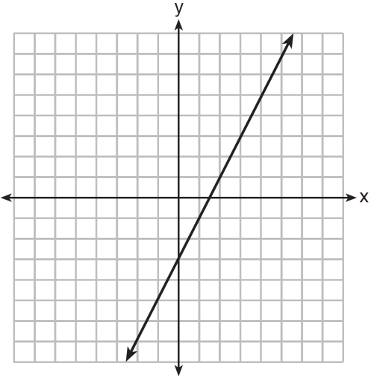

(1) $y=\frac{12-6x}{4}$ (3) $6y+x=18$
(2) $27+3y=6x$ (4) $y+3=6x$

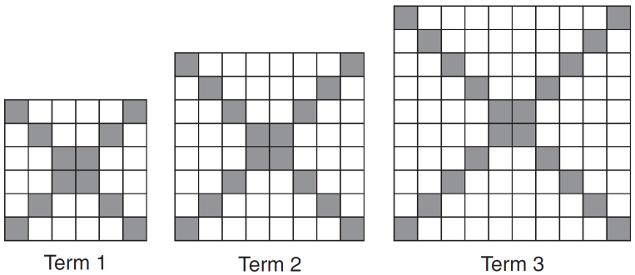
5. The diagrams below represent the first three terms of a sequence.

Assuming the pattern continues, which formula determines $a_{n}$, the number of shaded squares in the $n$th term?
(1) $a_{n}=4n+12$ (3) $a_{n}=4n+4$
(2) $a_{n}=4n+8$ (4) $a_{n}=4n+2$

