Name: Period: Job 13 Solving Systems By Elimination

Part 1: Textbook
Textbook Lesson 4-3 Pages 162-163: 15, 16, 20, 21, 23, 24, 34

Part 2: Algebra Regents Questions –

- Sandy programmed a website’s checkout process with an equation to calculate the amount customers will be charged when they download songs.

The website offers a discount. If one song is bought at the full price of $1.29, then each additional song is $.99. State an equation that represents the cost, $C$, when $s$ songs are downloaded.

Sandy figured she would be charged $52.77 for 52 songs. Is this the correct amount? Justify your answer.

2. The graph of $y=f(x)$ is shown below.
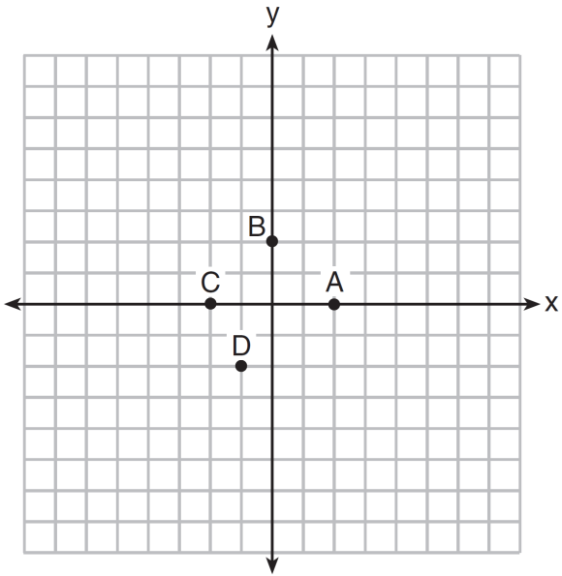

Which point could be used to find $f(2)$?
(1) A (3) C
(2) B (4) D

3. The function f has a domain of $\{1, 3, 5, 7\}$ and a range of $\{2, 4, 6\}$.
Could $f$ be represented by $\{\left(1, 2\right), \left(3, 4\right), \left(5, 6\right), \left(7, 2\right)\}$?
Justify your answer.

4. Which system of equations has the same solution as the system below?
$$2x+2y=16$$
$$3x-y=4$$

(1) $2x+2y=16$ (3) $x+y=16$
$6x-2y=4$ $3x-y=4$

(2) $2x+2y=16$ (4) $6x+6y=48$
$6x-2y=8$ $6x+2y=8$

5. Last week, a candle store received $355.60 for selling 20 candles. Small candles sell for $10.98 and large candles sell for $27.98. How many large candles did the store sell?
(1) $6$ (3) $10$
(2) $8$ (4) $12$

6. Determine the smallest integer that makes $-3x+7-5x<15$ true.

