Name: Period: Job 15 Systems of Linear Inequalities

Part 1: Textbook
Textbook Lesson 4-4 Pages 175-176: 16, 18, 20, 22
Part 2: Algebra Regents Questions –

- On the set of axes below, graph the inequality $2x+y>1$
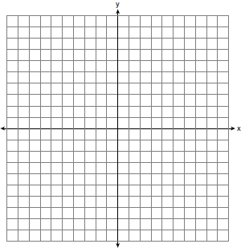
2. A gardener is planting two types of trees:
Type A is three feet tall and grows at a rate of 15 inches per year.
Type B is four feet tall and grows at a rate of 10 inches per year.
Algebraically determine exactly how many years it will take for these trees to be the same height.
**(hint: Must have the same units)

3.Subtract $57+3x-19$ from $5x^{2}+6x-12$. Express the result as a trinomial.

4. Which graph shows a line where each value of $y$ is three more than half of $x$?
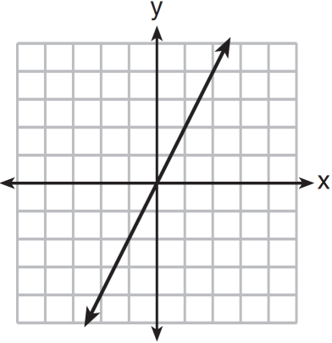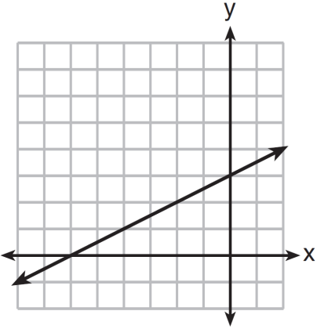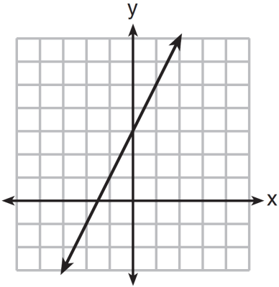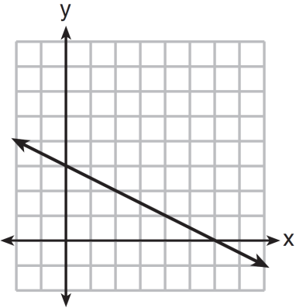
(1) (2) (3) (4)

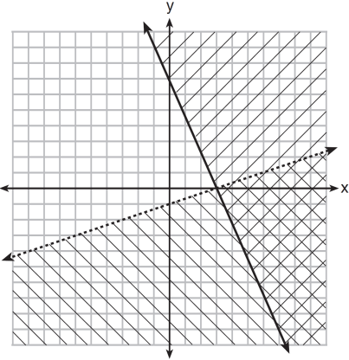
5. What is one point that lies in the solution set of the system of inequalities graphed below?

(1) $\left(7, 0\right)$ (3) $\left(0,7\right)$
(2) $(3, 0)$ (4) $(-3, 5)$

6. The Reel Good Cinema is conducting a mathematical study. In its theater, there are 200 seats. Adult tickets cost $12.50 and child tickets cost $6.25. The cinema's goal is to sell at least $1500 worth of tickets for the theater. Write a system of linear inequalities that can be used to find the possible combinations of adult tickets, x, and child tickets, y, that would satisfy the cinema's goal.

Graph the solution to this system of inequalities on the set of axes below. Label the solution with an S.

Marta claims that selling 30 adult tickets and 80 child tickets will result in meeting the cinema's goal. Explain whether she is correct or incorrect, based on the graph drawn

