Name: Period: Job 16 Absolute Value and Transformations

Students can identify the effect of replacing f(x) by f(x) + k, kf(x), f(kx), and f(x + k) for specific values of k (both positive and negative). Students can find the value of k given the graphs. Students will experiment with cases and illustrate an explanation of the effects on the graph using technology (IF-BF.B.3)

- To begin, use your calculator to complete the table and graph $y=\left|x\right|$

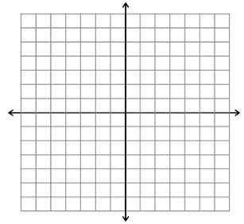
Remember, to graph absolute value on your calculator first press Y =, then press 2ND, then press 0, then press ENTER
Also, remember that for absolute value the graph must make a “v”.
x | y
Vertex:
Domain:
Range:

Complete the following and compare the graphs to the basic absolute value graph from number 1 above.

4. Using your own words and complete
sentences, describe what happened to the
basic absolute value graph when the
coefficient was a whole number.

- $y=2\left|x\right|$
- $y=3\left|x\right|$

- Graph $y=\frac{1}{2}\left|x\right|$

- Using your own words and complete sentences, describe what happened to the basic absolute value graph when the coefficient was a fraction.

______________________________________________
_______________________________________________

$7. y=\left|x\right|+2$ $8. y=\left|x\right|+3$
Vertex:
Domain:
Range:

- Using your own words and a complete sentence, describe how adding a number outside the absolute value changes the graph. ______

- Using what you just came up with from question 9, in your own words and complete sentences, describe how subtracting a number outside the absolute value might change the graph. (If you need help, use your calculator to graph $y=\left|x\right|-3$ and compare the differences)
______________________________________________________________________________________

- $y=\left|x+2\right|$
- $y=\left|x+3\right|$

Vertex:
Domain:
Range:

- Using your own words and a complete sentence, describe how adding a number inside the absolute value changes the graph.

- Using what you just came up with from question 13, in your own words and complete sentences describe how subtracting a number inside the absolute value might change the graph. (If you need help, use your calculator to graph $y=\left|x-3\right|$ and compare the differences)
16. Using your own words in a sentence or two, describe how a negative changes the basic absolute value graph.
$15. y=-\left|x\right|$

Vertex:
Domain:
Range:

Graph the following:

$$17. y=3\left|x\right|-2$$
18. $y=\left|x-5\right|+4$

Vertex:
Minimum or Maximum?
Increasing Interval:
Decreasing Interval:

Vertex:
Minimum or Maximum?
Increasing Interval:
Decreasing Interval:

- $y=-\left|x\right|+5$

- $y=-\left|x-2\right|-2$

Vertex:
Minimum or Maximum?
Increasing Interval:
Decreasing Interval:

Vertex:
Minimum or Maximum?
Increasing Interval:
Decreasing Interval:

Determine the equations for the following graphs.

- $y=$
- $y=$
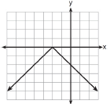
Vertex:
Minimum or Maximum?
Increasing Interval:
Decreasing Interval:

Vertex:
Minimum or Maximum?
Increasing Interval:
Decreasing Interval:

