Name: Period: Job 17 Piecewise Functions

Part 1: Textbook
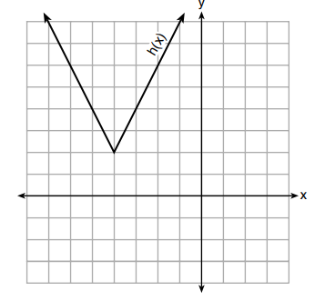
Textbook Lesson 5-2 Pages 195-196: 20, 21, 22, 26
Part 2: Algebra Regents Questions –

- The function $h(x)$, which is graphed to the right, and the function $g\left(x\right)=2\left|x+4\right|-3$ are given.

Which statements about these functions are true?
- $g\left(x\right)$ has a lower minimum value than $h(x)$
- For all values of $x, h(x)<g(x)$
- For any value of $x, g(x)≠h(x)$

(1) I and II, only (3) II and III, only
(2) I and III, only (4) I, II, and III

2. Graph the following function on the set of axes below.
$$f\left(x\right)=\left\{\begin{aligned}\left|x\right|, &- 3≤x<1 \\ 5, &1≤x≤6\end{aligned}\right.$$
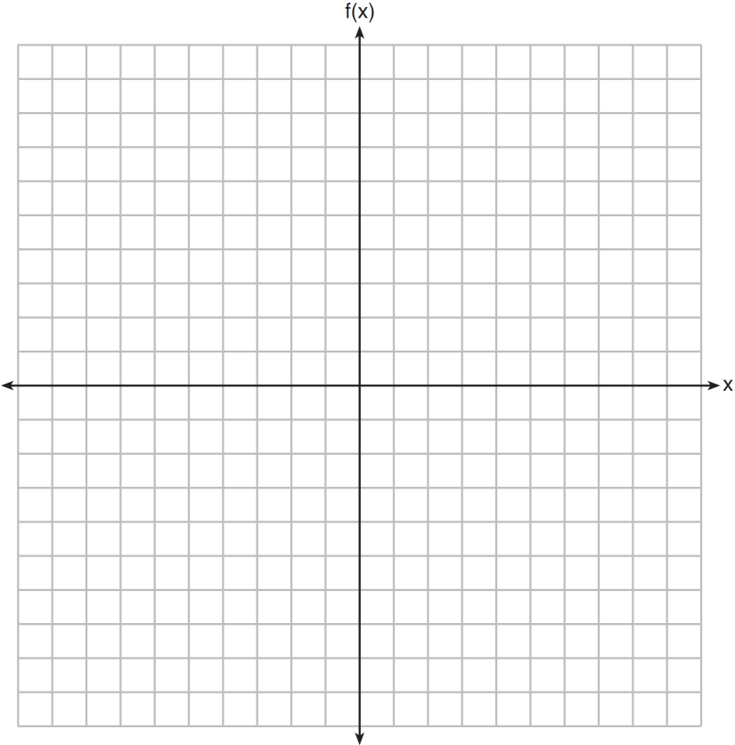

3. Joey enlarged a 3-inch by 5-inch photograph on a copy machine. He enlarged it four times. The table below shows the area of the photograph after each enlargement.
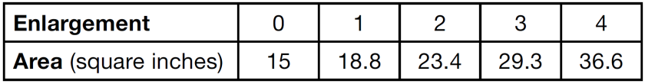

What is the average rate of change of the area from the original photograph to the third enlargement, to the nearest tenth?
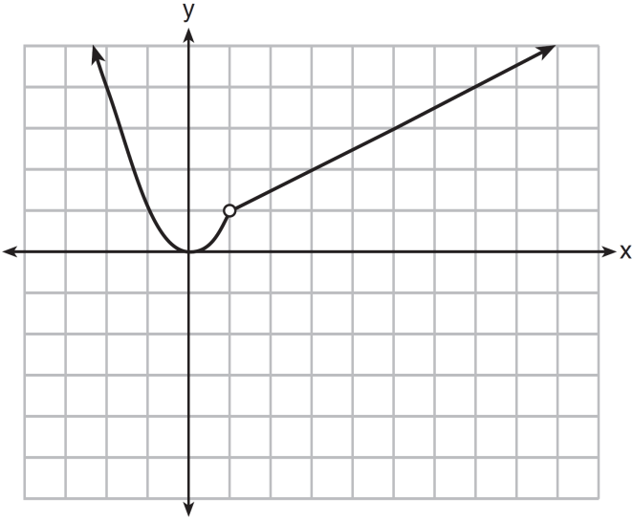
4. A function is graphed on the set of axes below.

Which function is related to the graph?
(1) $f\left(x\right)=\left\{\begin{aligned}x^{2} , &x<1 \\ x-2, &x>1\end{aligned}\right.$ (3) $f\left(x\right)=\left\{\begin{aligned}x^{2} , &x<1 \\ 2x-7, &x>1\end{aligned}\right.$
(2) $f\left(x\right)=\left\{\begin{aligned}x^{2} , &x<1 \\ \frac{1}{2}x+\frac{1}{2}, &x>1\end{aligned}\right.$ (4) $f\left(x\right)=\left\{\begin{aligned}x^{2} , &x<1 \\ \frac{3}{2}x-\frac{9}{2}, &x≥0\end{aligned}\right.$
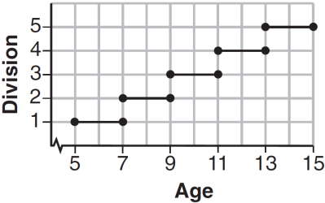
5. Is the graph shown to the right a function? Explain.

7. Graph the following function on the set of axes below.
