Name: Period: Job 19 Exponential Functions

Part 1: Textbook
Textbook Lesson 6-2 Page 228-229: 17,19, 21, 23, 24, 25
Part 2: Algebra Regents Questions –

- Some banks charge a fee on savings accounts that are left inactive for an extended period of time. The equation $y=5000{\left(0.98\right)}^{x}$ represents the value, $y,$ of one account that was left inactive for a period of $x$years. What is the y-intercept of this equation and what does it represent?
(1) 0.98, the percent of money in the account initially
(2) 0.98, the percent of money in the account after $x$ years
(3) 5000, the amount of money in the account initially
(4) 5000, the amount of money in the account after $x$ years

- Officials in a town use a function, C, to analyze traffic patterns. $C(n)$ represents the rate of traffic through an intersection where n is the number of observed vehicles in a specified time interval. What would be the most appropriate domain for the function?
(1) $\left\{…-2, -1, 0, 1, 2, 3, …\right\}$
(2) $\left\{-2, -1, 0, 1, 2, 3\right\}$
(3) $\left\{0,\frac{1}{2},1, 1\frac{1}{2},2, 2\frac{1}{2}\right\}$
(4) $\{0, 1, 2, 3, …\}$

3. Each day Toni records the height of a plant for her science lab. Her data are shown in the table below.
Day $(n)$ | $$1$$ | $$2$$ | $$3$$ | $$4$$ | $$5$$
Height $(cm)$ | $$3.0$$ | $$4.5$$ | $$6.0$$ | $$7.5$$ | $$9.0$$

Is this function linear or exponential? Explain.

Write a function to represent her data.

4. The inequality $7-\frac{2}{3}x<x-8$ is equivalent to
(1) $x>9$ (3) $x<9$
(2) $x>-\frac{3}{5}$ (4) $x<-\frac{3}{5}$

5. Write an exponential equation for the graph shown below.
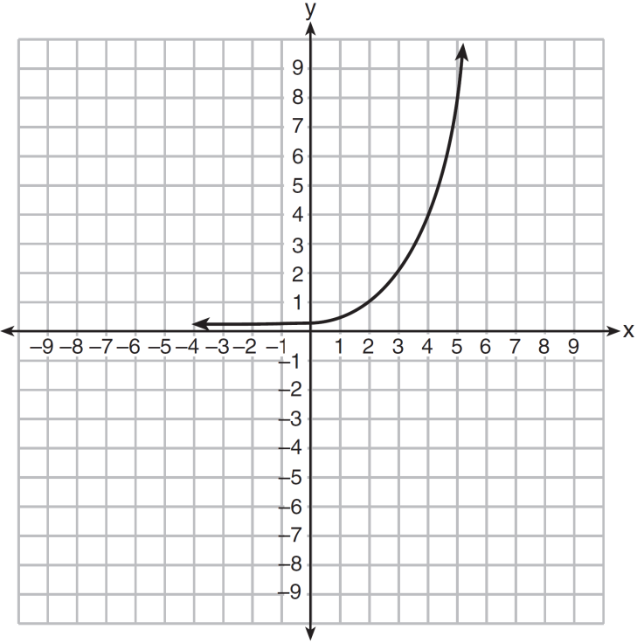
Explain how you determined the equation.

- An application developer released a new app to be downloaded. The table below gives the number of downloads for the first four weeks after the launch of the app.
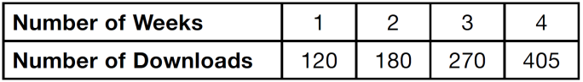

Write an exponential equation that models these data.

Use this model to predict how many downloads the developer would expect in the 26th week if this trend continues. Round your answer to the nearest download.

Would it be reasonable to use this model to predict the number of downloads past one year? Explain your reasoning.

