Name: Period: Job 20 Exponential Growth and Decay
Part 1: Textbook
Textbook Lesson 6-3 Pages 237-238: 15, 16, 19, 20, 23, 25, 27
Part 2: Algebra Regents Questions –

- The function $V\left(t\right)=1350{\left(1.017\right)}^{t}$ represents the value $V(t)$, in dollars, of a comic book$t$ years after its purchase. The yearly rate of appreciation of the comic book is
(1) $17\%$ (3) $1.017\%$
(2) $1.7\%$ (4) $0.017\%$

- Miriam and Jessica are growing bacteria in a laboratory. Miriam uses the growth function $f\left(t\right)=n^{2t}$ while Jessica uses the function $g\left(t\right)=n^{4t}$, where $n$ represents the initial number of bacteria and $t$ is the time, in hours. If Miriam starts with 16 bacteria, how many bacteria should Jessica start with to achieve the same growth over time?
(1) 32 (3) 16
(2) 8 (4) 4

3. A cell phone company charges $60.00 a month for up to 1 gigabyte of data. The cost of additional data is $0.05 per megabyte. If $d$ represents the number of additional megabytes used and $c$ represents the total charges at the end of the month, which linear equation can be used to determine a user’s monthly bill?
(1) $c=60-0.05d$ (3) $c=60d-0.05$
(2) $c=60.05d$ (4) $c=60+0.05d$

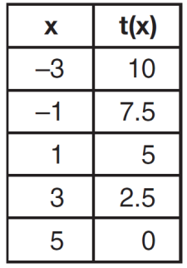
4. The function, $t(x)$, is shown in the table below.
Determine whether $t(x)$ is linear or exponential. Explain your answer.

5. The breakdown of a sample of a chemical compound is represented by the function $p\left(t\right)=300{\left(0.5\right)}^{t}$, where $p(t)$ represents the number of milligrams of the substance and$t$ represents the time, in years. In the function $p(t)$, explain what 0.5 and 300 represent.

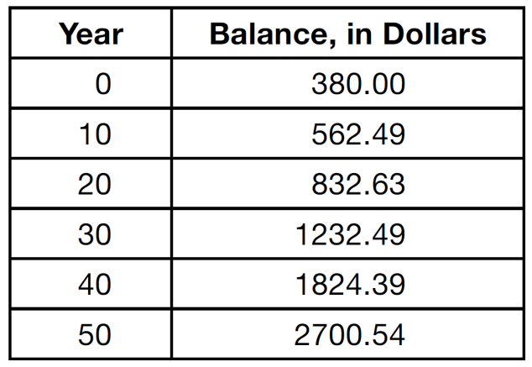
- The table below shows the average yearly balance in a savings account where interest is compounded annually. No money is deposited or withdrawn after the initial amount is deposited.

Which type of function best models the given data?
(1) linear function with a negative rate of change
(2) linear function with a positive rate of change
(3) exponential decay function
(4) exponential growth function

- Which situation could be modeled by using a linear function?

(1) a bank account balance that grows at a rate of 5% per year, compounded annually
(2) a population of bacteria that doubles every 4.5 hours
(3) the cost of cell phone service that charges a base amount plus 20 cents per minute
(4) the concentration of medicine in a person’s body that decays by a factor of one-third every hour

- The number of carbon atoms in a fossil is given by the function $y=5100{(0.85)}^{x}$, where $x$ represents the number of years since being discovered. Is this function growth or decay?

What is the percent of change each year? Explain how you arrived at your answer.

- Sofia and Theotis were given the information shown below about the bacteria growing in a Petri dish in their biology class.

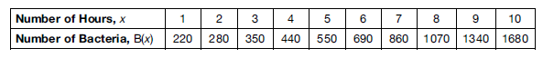

Sofia wants to model this information with a linear function. Marc wants to use an exponential function. Which model is the better choice? Explain why you chose this model.

