Name: Period: Job 21 Geometric Sequences

Part 1: Textbook
Textbook Lesson 6-4 Pages 244-245: 16, 39, 40
Part 2: Algebra Regents Questions –

- A laboratory technician studied the population growth of a colony of bacteria. He recorded the number of bacteria every other day, as shown in the partial table below.
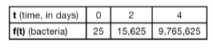
(1) $f\left(t\right)={25}^{t}$ (3) $f\left(t\right)=25t$
(2) $f\left(t\right)={25}^{t+1}$ (4) $f\left(t\right)=25(t+1)$

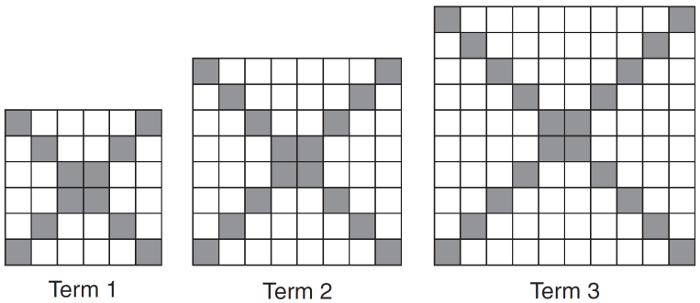
2. The diagrams below represent the first three terms of a sequence.

Assuming the pattern continues, which formula determines $a_{n}$, the number of shaded squares in the $n$th term?
(1) $a_{n}=4n+12$ (3) $a_{n}=4n+4$
(2) $a_{n}=4n+8$ (4) $a_{n}=4n+2$

3. Graph $g\left(x\right)=2^{x}$ for $x≥0$ on the set of axes below.

4. The value in dollars, $v(x)$, of a certain car after $x$ years is represented by the equation $v\left(x\right)=25,000{\left(0.86\right)}^{x}$. To the nearest dollar, how much more is the car worth after 2 years than after 3 years?
(1) 2589 (3) 15,901
(2) 6510 (4) 18,490

5. Alicia has invented a new app for smart phones that two companies are interested in purchasing for a 2-year contract. For each, name the type of function and create equation.
Company A is offering her $\$10,000$ for the first month and will increase the amout each month by $\$5000$.

Company B is offering $\$500$ for the first month and will double their payment each month from the previous month.

- The cost of a pack of chewing gum in a vending machine is $\$0.75$. The cost of a bottle of juice in the same machine is $\$1.25$. Julia has $\$22.00$ to spend on chewing gum and bottles of juice for her team and she must buy seven packs of chewing gum. If $b$represents the number of bottles of juice, which inequality represents the maximum number of bottles she can buy?
(1) $0.75b+1.25(7)≥22$ (3) $0.75(7)+1.25b≥22$
(2) $0.75b+1.25(7)≤22$ (4) $0.75(7)+1.25b≤22$

- An animal shelter spends $2.35 per day to care for each cat and $5.50 per day to care for each dog. Pat noticed that the shelter spent $89.50 caring for cats and dogs on Wednesday.
Write an equation to represent the possible numbers of cats and dogs that could have been at the shelter on Wednesday.

Pat said that there might have been 8 cats and 14 dogs at the shelter on Wednesday. Are Pat’s numbers possible? Use your equation to justify your answer.

Later, Pat found a record showing that there were a total of 22 cats and dogs at the shelter on Wednesday. How many cats were at the shelter on Wednesday?

