Name: Period: Job 22 Transformations of Exponential Functions

Part 1: Textbook
Textbook Lesson 6-5 Page 250: 19, 21, 23, 24, 25
Part 2: Algebra Regents Questions –
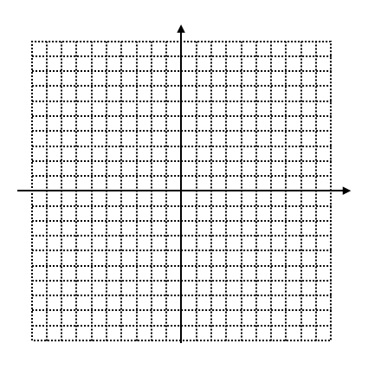
Graph Question 25 here

- Jacob and Jessica are studying the spread of dandelions. Jacob discovers that the growth over $t$ weeks can be defined by the function $f\left(t\right)=\left(8\right)∙2^{t}.$ Jessica finds that the growth function over $t$ weeks is $g\left(t\right)=2^{t+3}$. Calculate the number of dandelions that Jacob and Jessica will each have after 5 weeks.

Based on the growth from both functions, explain the relationship between $f(t)$ and $g(t)$.

- Which function is shown in the table below?
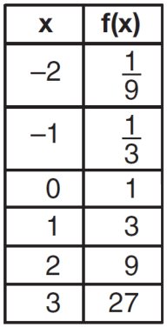

(1) $f\left(x\right)=3x$
(2) $f\left(x\right)=x+3$
(3) $f\left(x\right)=-x^{3}$
(4) $f\left(x\right)=3^{x}$

- The graph of $y=f(x)$ is shown below.
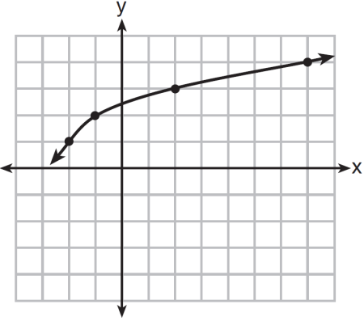

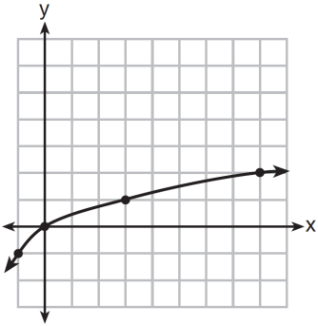
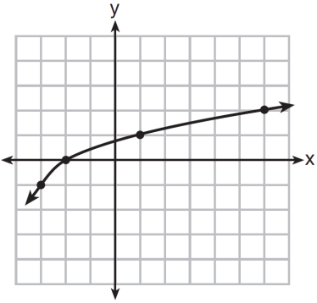
What is the graph of $y=f\left(x+1\right)-2$?

(1) (3)
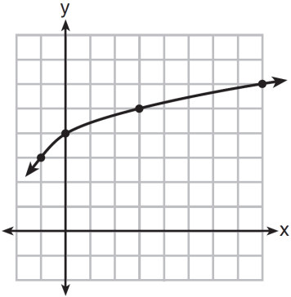
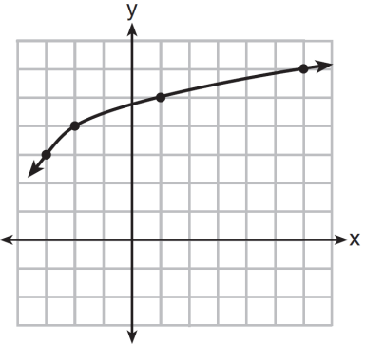

(2) (4)

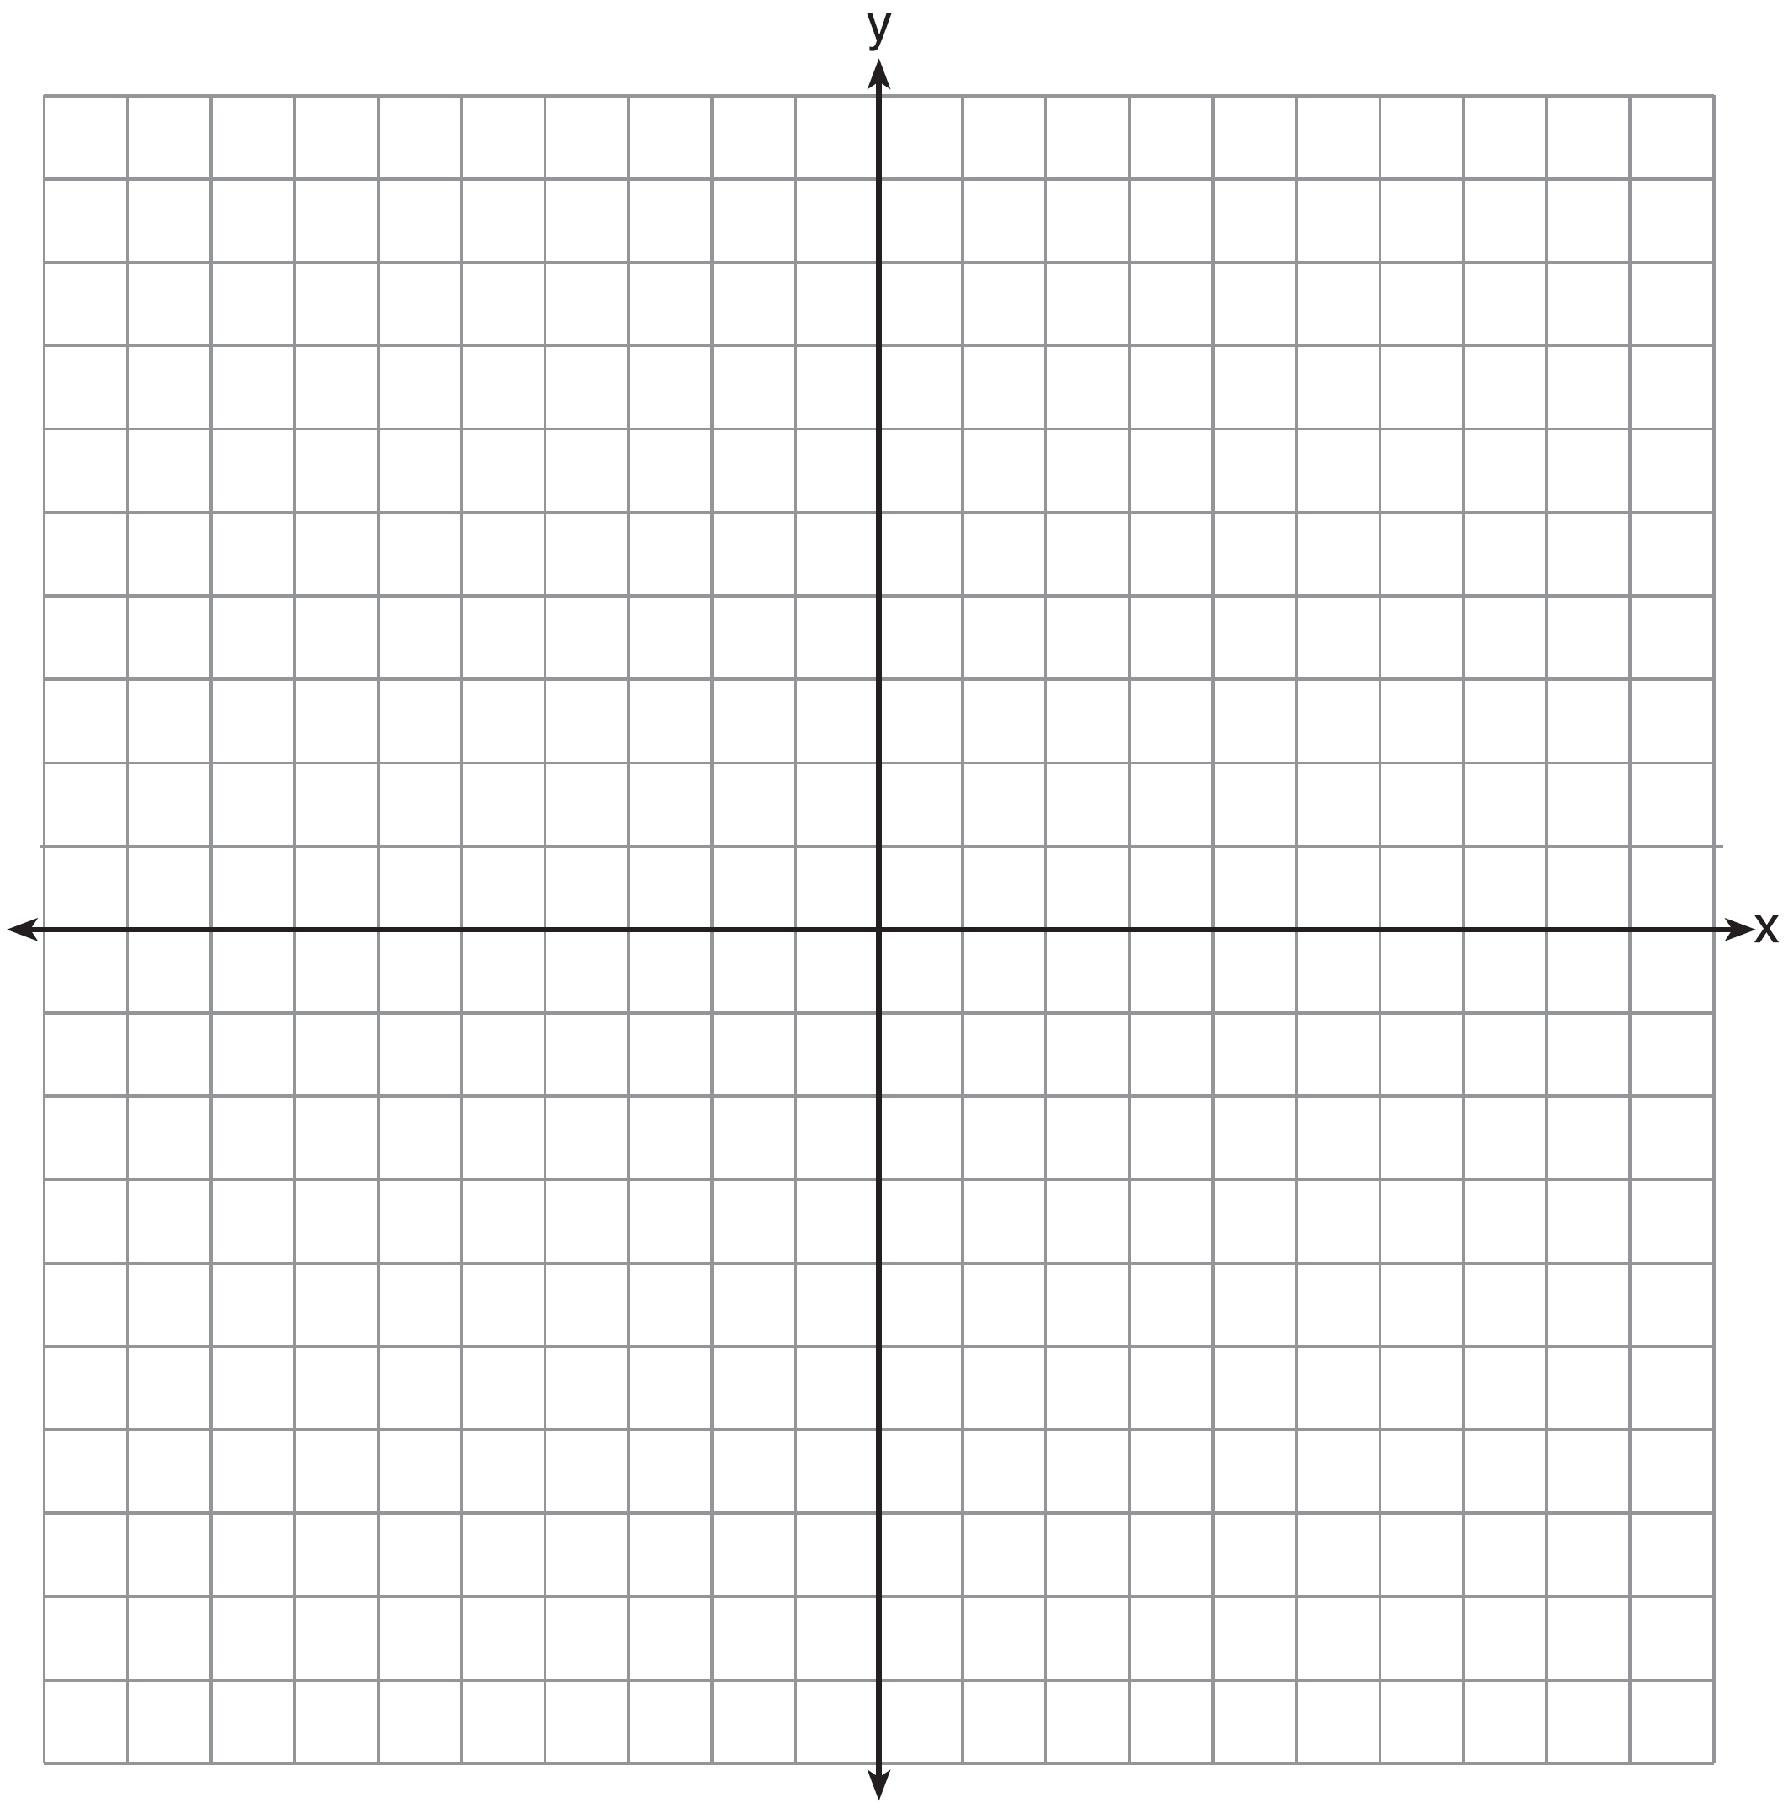
4. Draw the graph of $y=\sqrt{x-1}$ on the set of axes below.

