Name: Period: Job 24 Multiplying Polynomials

Part 1: Textbook
Textbook Lesson 7-2 Page 273-274: 18, 19. 22, 23, 27, 28, 32, 33, 34, 36, 37
Part 2: Algebra Regents Questions –

- Which trinomial is equivalent to $3{\left(x-2\right)}^{2}-2(x-1)$?

(1) $3x^{2}-2x-10$ (3) $3x^{2}-14x+10$
(2) $3x^{2}-2x-14$ (4) $3x^{2}-14x+14$

- Jakhari and Michael work at Lowe’s. Jakhari is paid $185 per week plus 3% of his total sales in dollars, $x$, which can be represented by $g\left(x\right)=185+0.03x$. Michael is paid $275 per week plus 2.5% of his total sales in dollars, $x$, which can be represented by $f\left(x\right)=275+0.025x$. Determine the value of x, in dollars, that will make their weekly pay the same.

- Express the product of $2x^{2}+7x-10$ and $x+5$ in standard form.

- Fred is given a rectangular piece of paper. If the length of Fred's piece of paper is represented by $2x-6$ and the width is represented by $3x-5$, then the paper has a total area represented by

(1) $5x-11$ (3) $10x-22$
(2) $6x^{2}-28x+30$ (4) $6x^{2}-6x-11$

- An on-line electronics store must sell at least $2500 worth of printers and computers per day. Each printer costs $50 and each computer costs $500. The store can ship a maximum of 15 items per day. On the set of axes below, graph a system of inequalities that models these constraints.

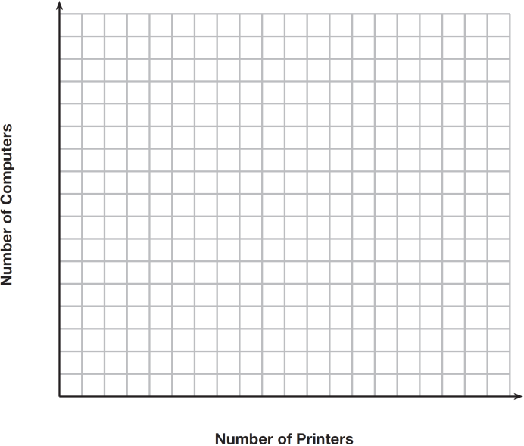

Determine a combination of printers and computers that would allow the electronics store to meet all of the constraints. Explain how you obtained your answer.

- John has four more nickels than dimes in his pocket, for a total of $1.25. Which equation could be used to determine the number of dimes, $x$, in his pocket?
(1) $0.10\left(x+4\right)+0.05\left(x\right)=\$1.25$
(2) $0.05\left(x+4\right)+0.10\left(x\right)=\$1.25$
(3) $0.10\left(4x\right)+0.05\left(x\right)=\$1.25$
(4) $0.05\left(4x\right)+0.10\left(x\right)=\$1.25$

