Name: Period: Job 28 Factoring Completely and Special Cases
Part 1: Textbook
Textbook Lesson 7-6 Page 299: 37, 40, 41
Textbook Lesson 7-7 Page 305: 31, 32, 33, 35, 38

Part 2: Algebra Regents Questions –

- The expression $49x^{2}-36$ is equivalent to

- ${(7x-6)}^{2}$ (3) $(7x-6)(7x+6)$
- ${(24.5x-18)}^{2}$ (4) $(24.5x-18)(24.5x+18)$

- Factor the expression ${16x}^{4}-64$.

- Which expression is equivalent to ${16x}^{2}-36$?

- $4(2x-3)(2x-3)$ (3) $(4x-6)(4x-6)$
- $4(2x+3)(2x-3)$ (4) $(4x+6)(4x+6)$

- Factor the expression $x^{4}+6x^{2}-7$ completely.

- When factored completely, the expression $p^{4}-81$ is equivalent to

(1) $(p^{2}+9)(p^{2}-9)$ (3) $(p^{2}+9)(p+3)(p-3)$
(2) $(p^{2}-9)(p^{2}-9)$ (4) $(p+3)(p-3)(p-3)$

- When factored completely, $x^{3}-13x^{2}-30x$ is

(1) $x\left(x+3\right)\left(x-10\right)$ (3) $x\left(x+2\right)\left(x-15\right)$
(2) $x(x-3)(x-10)$ (4) $x(x-2)(x+15)$

- On the axes below, graph $f\left(x\right)=\left|2x\right|$
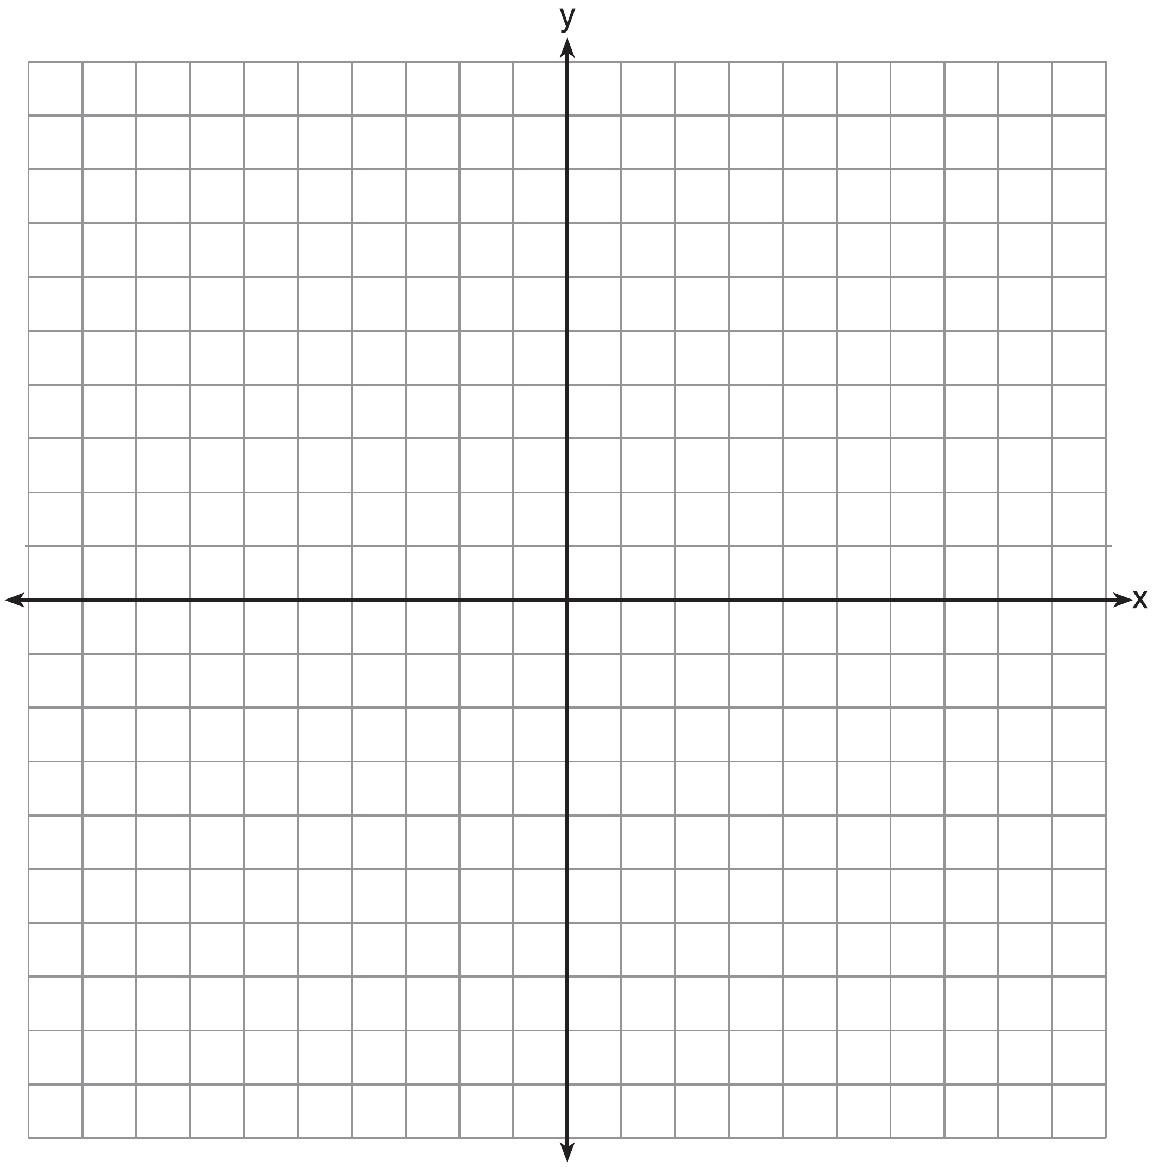
If $g\left(x\right)=f\left(x\right)-4$, how is the graph of $f(x)$ translated to form the graph of $g(x)$?

If $h\left(x\right)=f\left(x-3\right)$, how is the graph of $f(x)$ translated to form the graph of $h(x)$?

- Two friends went to a restaurant and ordered one plain pizza and two sodas. Their bill totaled $15.95. Later that day, five friends went to the same restaurant. They ordered three plain pizzas and each person had one soda. Their bill totaled $45.90. Write and solve a system of equations to determine the price of one plain pizza.

