Lesson 8.1 Page 320: 14, 15, 16, 22, 24, 25, 26, 30

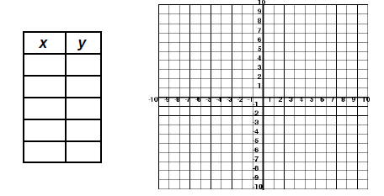
1.$Graph f\left(x\right)=x^{2}$
Vertex: _________Max or Min?_________
Axis Of Symmetry: _________
Domain:__________________
Range:___________________
Zeros:___________________
Number of solutions: _______
- $Graph y=x^{2}+2x+5$
Vertex: _________Max or Min?_______
Axis Of Symmetry: _________
Domain:__________________
Range:___________________
Zeros:___________________
Number of Solutions: ______

- $Graph h(t)={-2t}^{2}+8t$
Vertex: _________Max or Min?_______
Axis Of Symmetry: _________
Domain:__________________
Range:___________________
Zeros:____________________
Number of Solutions: _______

- An apple is launched directly upward at 64 feet per second from a platform 80 feet high. The equation for this apple’s height $h$ at time $t$ seconds after launch is $h\left(t\right)=-16t^{2}+64t+80$.

- What is the maximum height of the apple?

- How many seconds will it take the apple to reach the ground?

- State the time interval, in seconds, during which the height of the object decreases.

- If$f\left(x\right)=\frac{1}{4}x^{2}-( \frac{1}{2}x+3)$, what is the value of $f(12)$?

- A toy rocket is launched from the ground straight upward. The height of the rocket above the ground, in feet, is given by the equation, where t is the time in seconds. Determine the domain for this function in the given context. Explain your reasoning.

- A skydiver, James, jumps out of a plane. The distance, d(t), in meters, James travels after t seconds falling to the ground can be modeled by the function d(t) =.5t². What is the average speed, in meters per second, of the skydiver, James, between 2 and 5 seconds after jumping out of the plane?

- Determine the smallest integer that makes -3x + 7 - 5x < 15 true.

