Name Job 2 Solving Equations
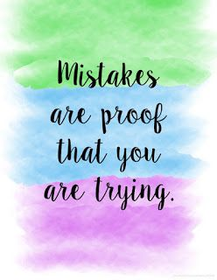

Part 1: Textbook - Required:
Textbook Lesson 1-2: 10, 12, 16, 18, 20, 22, 24, 26, 28, 32, 36, 41

Part 2: Algebra Regents Questions – Required:

- The expression $3\left(x^{2}-1\right)-(x^{2}-7x+10)$ is equivalent to
  - $2x^{2}-7x+7$
  - ${2x}^{2}+7x-13$
  - ${2x}^{2}-7x+9$
  - ${2x}^{2}+7x-11$

- Determine if the product of $3\sqrt{2}$ and $8\sqrt{18}$ is rational or irrational. Explain your answer.

- A part of Jennifer’s work to solve the equation $2\left(6x^{2}-3\right)=11x^{2}-x$ is shown below.

Given: $2\left({6x}^{2}-3\right)=11x^{2}-x$
Step 1: $12x^{2}-6=11x^{2}-x$

Which property justifies her first step?
- Identify property of multiplication
- Multiplication property of equality
- Commutative property of multiplication
- Distributive property of multiplication over subtraction

- Solve the equation below for $y$

Part 3 Advanced – Optional: Bonus 8, 30, 31

