Name: Period: Job 38: Counts Double! (3 Day Assignment)
Job 38: Lesson 10.1 – 10.3 Cube Root Functions, Translations, Axis of Symmetry, Rate of Change
Part 1: Lesson 10.1- 10.3 Textbook
Lesson 10-1: Page 415: 9, 10, 17a, 24, 25
Lesson 10-2: Page 423: 26 (Graph Only), 29
Lesson 10-3: Page 429: 4, 5, 6, 14, 17 (Graph, ID Domain and Range, Draw and state the Axis of Symmetry
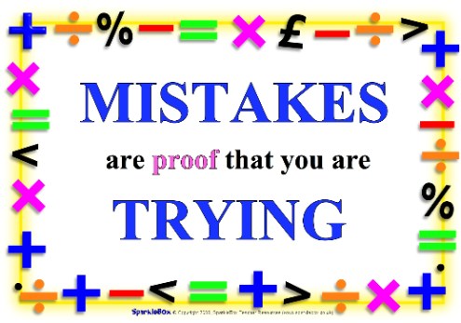
Questions for 14 and 17)

Part 2: Algebra Regents Questions –

- The graph below shows the distance in miles, $m$, hiked from a camp in $h$ hour. Which interval had the greatest rate of change?
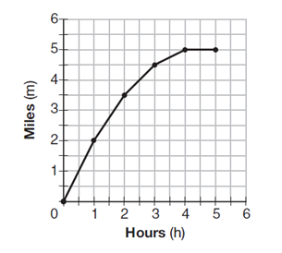
- Hour 0 to hour 1 (3) hour 2 to hour 3
- Hour 1 to hour 2 (4) hour 3 to hour 4

- Janice is asked to solve $0={64x}^{2}+16x-3$. She begins the problem by writing the following steps:
Line 1 $0={64x}^{2}+16x-3$
Line 2 $0=B^{2}+2B-3$
Line 3 $0=(B+3)(B-1)$
Use Janice’s procedure to solve the equation for $x$.

Explain the method Janice used to solve the quadratic equation.

- For a class picnic, two teachers went to the same store to purchase drinks. One teacher purchased 18 juice boxes and 32 bottles of water, and spent $19.92. The other teacher purchased 14 juice boxes and 26 bottles of water , and spent $15.76. Write a system of equations to represent the costs of a juice box, $j$, and a bottle of water, $w$.

Kara said that the juice boxes might have cost 52 cents each and that the bottles of water might have cost 33 cents each. Use your system of equations to justify that Kara’s prices are not possible.

Solve your system of equations to determine the actual cost, in dollars, of each juice box and each bottles of water.

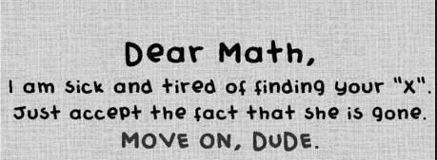
- Officials in a town use a function, $C$, to analyze traffic patterns. $C(n)$ represents the rate of traffic through an intersection where $n$ is the number of observed vehicles in a specified time interval. What would be the most appropriate domain for the function?
- $\left\{…-2, -1, 0, 1, 2, 3, …\right\}$ (3) $\{0, \frac{1}{2}, 1, 1\frac{1}{2}, 2, 2\frac{1}{2}\}$
- $\{-2, -1, 0, 1, 2, 3\}$ (4) $\{0, 1, 2, 3, …\}$

- If $A={3x}^{2}+5x-6$ and $B={-2x}^{2}-6x+7$, then $A-B$ equals
- ${-5x}^{2}-11x+13$ (3) ${-5x}^{2}-x+1$
- ${5x}^{2}+11x-13$ (4) ${5x}^{2}-x+1$

- What are the roots of the equation $x^{2}+4x-16=0$?
- $2±2\sqrt{5}$ (3) $2±4\sqrt{5}$
- $-2±2\sqrt{5}$ (4) $-2±4\sqrt{5}$

