Name: Period: Job 39: Lesson 10-4 Translations of Functions
Part 1: Lesson 10-4 Textbook
Page 436: 17, 20, 21 Draw & State the Axis of Symmetry if one. State how the graph translated from the parent function
Page 436: 25, 27, 33

Part 2: Algebra Regents Questions –

- On the set of axes below, graph
$$h\left(x\right)=\frac{-1}{2}x+2$$

and

$$f\left(x\right)=\left\{\begin{aligned}2x+1, x≤-1 \\ 2-x^{2}, x>-1\end{aligned}\right.$$

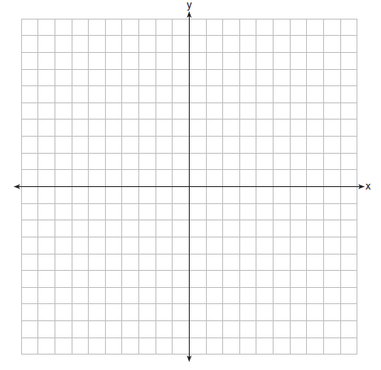

How many values of $x$ satisfy the equation $f\left(x\right)=h(x)$? Explain your answer, using evidence from your graphs.

3.

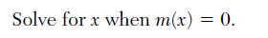

4.
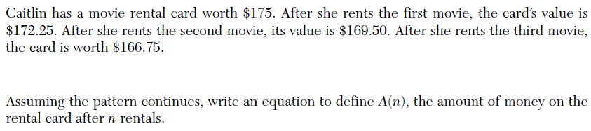

5.
