Name Job 3 Solving Equations

Part 1: Textbook - Required:
Textbook Lesson 1-3: 10, 12, 16, 17, 18, 22, 16, 29, 30, 38

Part 2: Algebra Regents Questions – Required:

1.
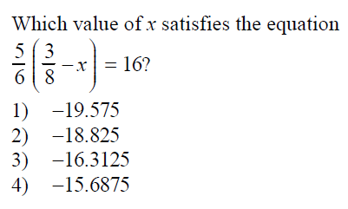

2.
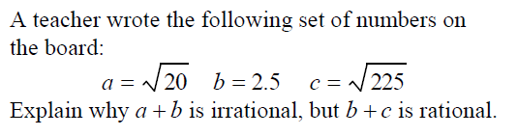

3. When $3x+2=5(x-4)$ is solved for x, the solution is

Part 3 Advanced – Optional: Bonus 15, 27, 37

