Name: Period: Job 45: Lesson 11-5 Two Way Frequency Tables
Part 1: Lesson 11-5 Textbook – No Questions

Part 2: Algebra Regents Questions –

1. A survey of 100 students was taken. It was found that 60 students watched sports, and 34 of these students did not like pop music. Of the students who did not watch sports, 70% liked pop music. Complete the two-way frequency table.

 | Watch Sports | Don’t Watch Sports | Total
Like Pop
Don’t Like Pop
Total

2. A radio station did a survey to determine what kind of music to play by taking a sample of middle school, high school, and college students. They were asked which of three different types of music they prefer on the radio: hip-hop, alternative, or classic rock. The results are summarized in the table below.
 | Hip-Hop | Alternative | Classic Rock
Middle School | 28 | 18 | 4
High School | 22 | 22 | 6
College | 16 | 20 | 14

What percentage of college students prefers classic rock?
1) | 14% | 3) | 33%
2) | 28% | 4) | 58%

3. A public opinion poll was taken to explore the relationship between age and support for a candidate in an election. The results of the poll are summarized in the table below.

Age | For | Against | No Opinion
21-40 | 30 | 12 | 8
41-60 | 20 | 40 | 15
Over 60 | 25 | 35 | 15
What percent of the 21-40 age group was for the candidate?
1) | 15 | 3) | 40
2) | 25 | 4) | 60

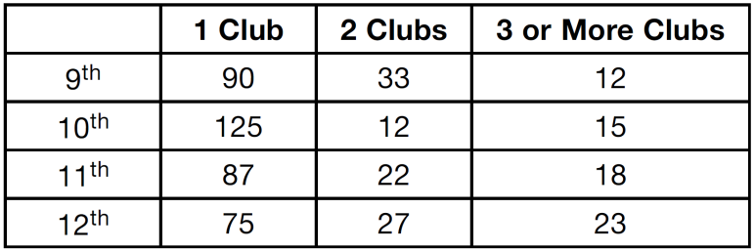
4. The school newspaper surveyed the student body for an article about club membership. The table below shows the number of students in each grade level who belong to one or more clubs.

If there are 180 students in ninth grade, what percentage of the ninth grade students belong to more than one club?

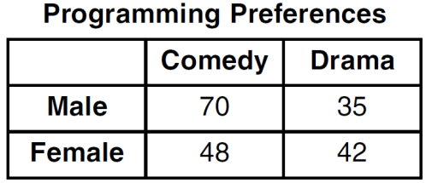
5. A statistics class surveyed some students during one lunch period to obtain opinions about television programming preferences. The results of the survey are summarized in the table below.

Based on the sample, predict how many of the school’s 351 males would prefer comedy. Justify your answer.

6. The data table below shows the median diameter of grains of sand and the slope of the beach for 9 naturally occurring ocean beaches.

Median Diameter of  Grains of Sand,  in Millimeters (x) | 0.17 | 0.19 | 0.22 | 0.235 | 0.235 | 0.3 | 0.35 | 0.42 | 0.85
Slope of Beach,  in Degrees (y) | 0.63 | 0.7 | 0.82 | 0.88 | 1.15 | 1.5 | 4.4 | 7.3 | 11.3

Write the linear regression equation for this set of data, rounding all values to the nearest thousandth. Using this equation, predict the slope of a beach, to the nearest tenth of a degree, on a beach with grains of sand having a median diameter of 0.65 mm.

7.

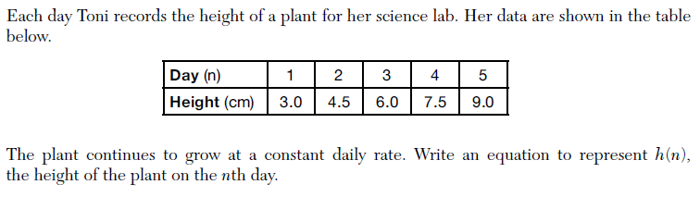

8. Solve for $x$: ${(x+1)}^{2}=16$. State if the solution is rational or irrational and why.

9. Given -20x + 7x – 8 > - 32, determine the largest integer value that satisfies this inequality.

- Rameke is asked to transform the graph of $b(x)$ below.

The graph of $b(x)$ is transformed using the equation $h\left(x\right)=b\left(x-8\right)-2$. Describe how the graph of $b(x)$ changed to form the graph of $h(x)$.

