Name Job 4 Rearranging Formulas

Part 1: Textbook - Required:
Textbook Lesson 1-4: 1, 4, 13, 15, 17, 19, 21, 23, 25

Part 2: Algebra Regents Questions – Required:

- Using the formula for the volume of a cone, express $r$ in terms of $V, h,$ and $π$.
$$V=\frac{1}{3}πr^{2}$$

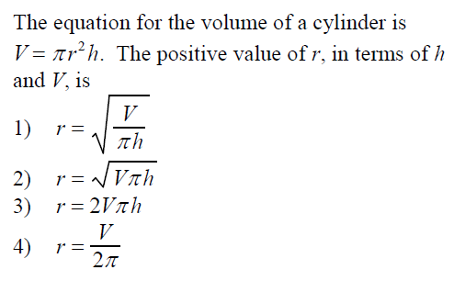

- Is the sum of and rational or irrational? Explain your answer.

- Solve the equation below to determine and state the smallest possible value for x in the solution set.

$$3\left(x+3\right)=5x-3$$

Part 3 Advanced – Optional: Bonus 11, 33

