Name: Job 6 Slope Intercept Form/ Graphing Lines
(3 days)
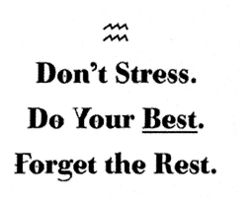
Part 1: Textbook
Textbook Lesson 2-1 Page 60: 7,8, 9, 10, 11, 24, 29

Part 2: Algebra Regents Questions –

- Which function has a constant rate of change equal to $-3$?
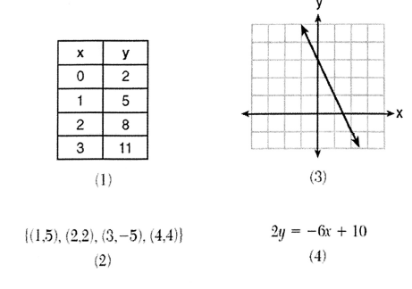

- Michael borrows money from his uncle, who is charging him simple interest using the fomula $I=Prt$. To figure out what the interest rate, $r$, is, Michael rearranges the formula to find $r$. His new formula is $r$ equals

- $\frac{I-P}{t}$ (2) $\frac{P-I}{t}$ (3) $\frac{I}{Pt}$ (4)$\frac{Pt}{I}$

- During a recent snowstorm in Red Hook, NY. Jaime noted that there were 4 inches of snow on the ground at 3:00 p.m., and there were 6 inches of snow on the ground at 7:00 p.m. If she were to graph these data, what does the slope of the line connecting these two points represent in context of this problem?

