Name Job 7 Relations and Functions

Part 1: Textbook
Textbook Lesson 3-1 Page 92: 5, 8, 13, 14, 18, 19

Part 2: Algebra Regents Questions –

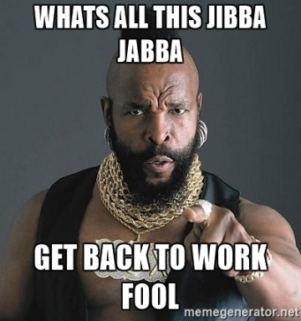
1. Kyonnah wants to watch a varsity basketball game and found out that spectators must buy a ticket at the door. The cost of an adult ticket is $4.00 and the cost of a student ticket is $2.00. If the number of adult tickets sold is represented by a and the student tickets sold by s, which expression is represented the amount of money collected at the door from the ticket sales?

1) 6.00as
2) 6(a + s)
3) (4a)(2s)
4) 4a + 2s

2. Help Ashantae draw the graph of the equation $y=-\frac{1}{3}x+6$

3. Help Josiah draw the graph of the equation $f\left(x\right)=\frac{2}{5}x-6$

5. A function is defined as $\left\{\left(0,1\right), \left(2,3\right), \left(5,8\right), (7,2)\right\}$. Paul is asked to create one more ordered pair for the function. Which ordered pair can he add to the set to keep it a function?

- $\left(0,2\right)$ (2) $\left(7,0\right)$ (3) $\left(5,3\right)$ (4) $\left(1,3\right)$

6. Axavion says $\left\{\left(-1,9\right), \left(2,7\right),\left(0,7\right),(5,2)\right\}$ is a function. Naya says it is not a function. Who is correct? Explain your answer.

7. Azariah paid $600 for a new guitar. Her guitar cost $40 more than twice the cost of her friend’s guitar. How much did her friend’s guitar cost?

8. Kerwin wants to join a gym. He found out that membership for the Alpine rock – climbing gym costs $25 per month plus a 125 sign up fee. Membership for Rocco’s Rock climbing gym costs 30 per month plus a 50 sign up fee.

- After how many months will the membership cost the same?

- If you only want a one year membership, which gym would you choose and why?

9. State the Domain and Range of the following:
a) (- 4, 5), (-3, 3), (6, -2), (-4, -2)

b) 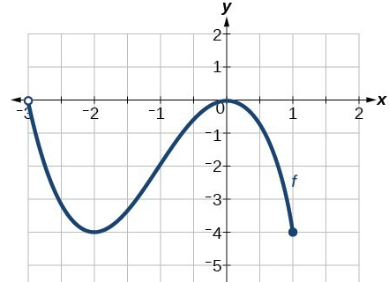

c) 