Name Job 8 Function Notation

Part 1: Textbook
Textbook Lesson 3 - 2 Page 100: 13, 15, 19, 20, 22, 30a
Part 2: Algebra Regents Questions –

- Find the value of $f(-1)$ for the function $f\left(x\right)=-2x+6$. Show all work.

2. Solve for y and graph the equation: $8x-2y=14$
a) State the rate of change
b) State the y - intercept
3. The cost of a pack of chewing gum in a vending machine is $0.75. The cost of a bottle of juice in the same machine is $1.25. Julia has $22.00 to spend on chewing gum and bottles of juice for her team and she must buy seven packs of chewing gum. If b represents the number of bottles of juice, which inequality represents the maximum number of bottles she can buy?

- $0.75b+1.25(7)≥22$ (3) $0.75\left(7\right)+1.25b≥22$
- $0.75b+1.25(7)≤22$ (4) $0.75\left(7\right)+1.25b≤22$
4. For which value of $P$ and $W$ is $P+W$ a rational number?

- $P=\frac{1}{\sqrt{3}} and W=\frac{1}{\sqrt{6}}$
(2) $P=\frac{1}{\sqrt{4}} and W=\frac{1}{\sqrt{9}}$
(3) $P=\frac{1}{\sqrt{6}} and W=\frac{1}{\sqrt{10}}$
(4) $P=\frac{1}{\sqrt{25}} and W=\frac{1}{\sqrt{2}}$
5. The owner of a small computer repair business has one employee, who is paid an hourly rate of $22. The owner estimates his weekly profit using the function $P\left(x\right)=8600-22x$. In this function, $x$ represents the number of
(1) computers repaired per week
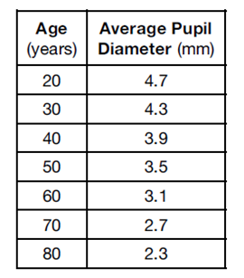
(2) hours worked per week
(3) customers served per week
(4) days worked per week
6. The table to the right shows the average diameter of a pupil in a person’s eye as he or she grows older. What is the average rate of change, in millimeters per year, of a person’s pupil diameter from age 20 to 80?
(1) $2.4$ (2) $-2.4$ (3) $0.04$ (4) $-0.04$

7. If $f\left(x\right)=\frac{\sqrt{{4x}^{2}-1}}{2x+1}$ and $g\left(x\right)={2x}^{2}-x$, find each value.
- $f(-1)$ b) $g(\frac{1}{2})$

8.
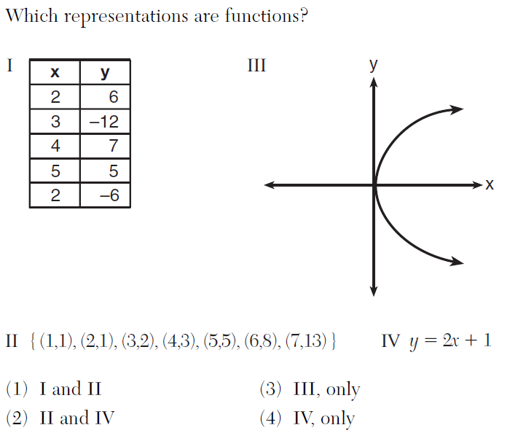

9. Myasia wants to rent a community recreation center. They charge a fixed fee of $55 plus $175 per hour to rent their facilities.
- Write an equation that shows the total cost, c of renting the recreation center for h hours.

b) Determine the total cost for Myasia to rent the recreation center for 5 hours.

