Name: ________________________ Algebra Chapter 4 Review
- Graph the following inequality below: $y>-\frac{1}{2}x+3$
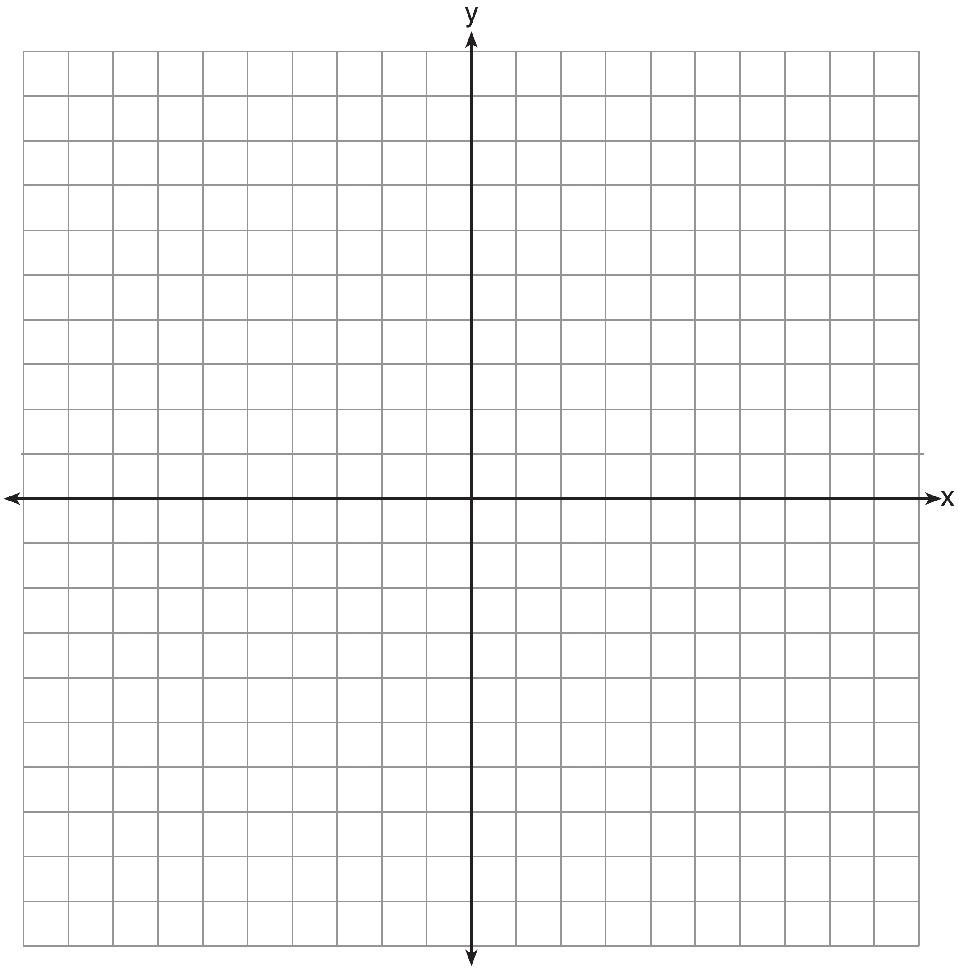

- Graph the following system of equations on the grid below.
$$f(x)=2x+6$$
$$g\left(x\right)=\frac{1}{2}x$$
Using the graph, determine when$f\left(x\right)=g(x)$.

- Graph the system of inequalities. Label the solution area S.
$y ≤ \frac{1}{2} x+2$
$y < -2x-3$
Determine if the following points are in the solution set:
(-3, -2) (-2, 1) (0, -2) (4,-4)

- Malia has $500 to purchase water bottles and pairs of socks for a fundraiser for her school’s cross-country team. Water bottles cost $2 each, and socks cost $3 per pair. She needs to buy a total of at least 200 items without buying too many of just one item.

  - Write a system of linear inequalities to represent the situation, where x represents the number of water bottles and y represents the number of pairs of socks.

  - Graph the system of inequalities on the grid below.

  - State a possible combination of water bottle and sock pair purchases that would satisfy this scenario.

- Two pizzas and four sandwiches cost $62. Four pizzas and ten sandwiches cost $140.
  - Write a system of equations for the above situation.
  - Using your equations, solve for the cost of pizzas and sandwiches.

- Which system of equations has the same solution as the system below?
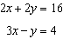
1) | 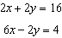 | 2) | 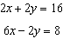 | 3) | 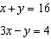 | 4) | 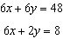
- Nate starts a lawn-mowing business. In his business, he has expenses and revenue. Nate’s expenses are the cost of the lawn mower and gas, and his revenue is $25 per lawn. If his expenses are given by the equation $f\left(x\right)=2x+200$, and income is given by the equation $g\left(x\right)=25x$, at what point will Nate’s revenue be the same as his expenses?

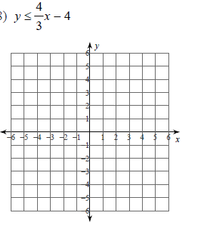
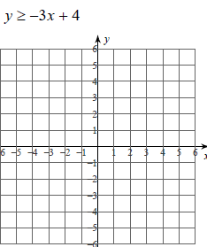
- Colleen could not figure out how to finish graphing inequalities. Help her finish by determining if she should connect with a solid or dashed line. Then determine shade up or down!
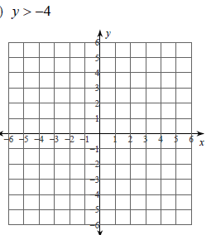

- MATCH THE DESCRIPTIONS WITH THR GRAPH THAT REPRESENTS IT!

$x>2$ $y≤2$ $y<2$ $y≥2$

- In the graph of an inequality, the area below a dashed line through the points $(-5,2)$ and $(3,2)$ is shaded

- In the graph of an inequality, the area below a solid line through the points $(-5,2)$ and $(3,2)$ is shaded

- In the graph of an inequality, the area above a solid line through the points $(-5,2)$ and $(3,2)$ is shaded

- In the graph of an inequality, the area to the right of a dashed line through the points $(2,-5)$ and $(2, 3)$ is shaded

