Name: ______________________ Unit 8- Quadratic Functions Review Alg 1
- On the set of axes below, draw the graph of$\left(x\right)=-x^{2}+5x+1$ .
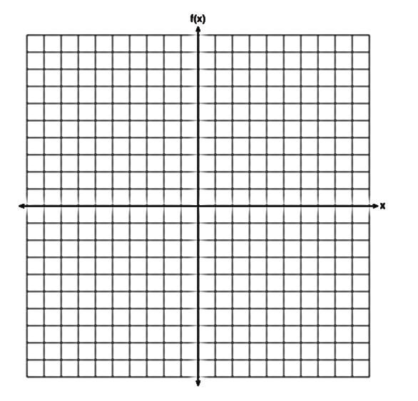
Is the vertex a maximum or a minimum?

State the vertex of the equation.

- The graph below shows the function $f(x)$.
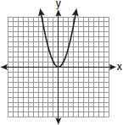
On the same grid, graph the following, then state the vertex for each:
- $g\left(x\right)=f(x-2)$
- $h\left(x\right)=f\left(x\right)+2$
- $j\left(x\right)=f\left(x+4\right)-5$
- A football player attempts to kick a football over a goal post. The path of the football can be modeled by the function $h\left(t\right)=-\frac{1}{225}x^{2}+\frac{2}{3}x$, where x is the horizontal distance from the kick, and $h(x)$ is the height of the football above the ground, when both are measured in feet. On the set of axes below, graph the function $y=h(x)$ over the interval $0≤x≤150$.
Determine the vertex of $y=h(x)$.

Interpret the meaning of this vertex in the context of the problem.

- The graph of the function $f(x)$ is shown below.
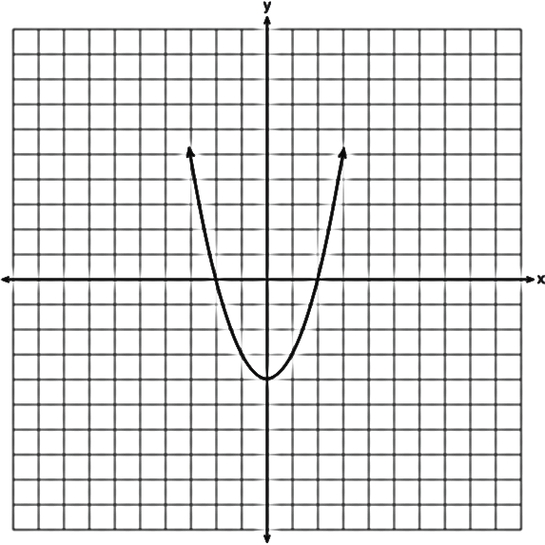
Describe what happens to the graph with each of the transformations:
- The leading coefficient is multiplied by $-\frac{1}{2}$

- The leading coefficient is multiplied by $-4$

- Let $f$ be the function represented by the graph below.
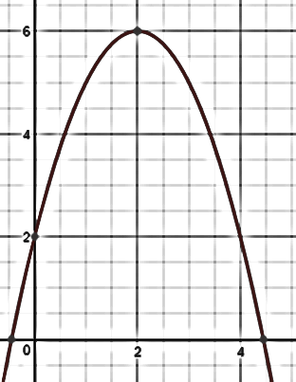

Let $g$ be a function such that $g(x)$=$-\frac{1}{3}x^{2}+6x+4$.

State the maximum value for each and explain how your arrived at your answer.

Determine which function has the larger maximum value.

- At an office supply store, if a customer purchases fewer than 10 pencils, the cost of each pencil is $1.75. If a customer purchases 10 or more pencils, the cost of each pencil is $1.25. Let c be a function for which$c\left(x\right)$is the cost of purchasing x pencils, where x is a whole number.
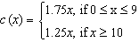
Determine the difference in costs, in dollars, 8 pencils versus 15 pencils.

Determine the number of pencils that must be ordered for the cost to be $16.25. Explain how you arrived at this answer.

- If $f\left(x\right)=\frac{x}{x²-16}$, what is the value of $f(-10)$?
1) |  | 2) |  | 3) |  | 4)
- A toy rocket is launched from the ground straight upward. The height of the rocket above the ground, in feet, is given by the equation $h\left(t\right)=-16t^{2}+64t$, where t is the time in seconds. Determine the average speed of the rocket between 0 and 2 seconds after it was launched.

- Determine whether each scenario is linear, quadratic, or exponential.
  - Two friends are having a catch. The ball is thrown 20 feet between the two friends and reaches a maximum height of 18 feet halfway between the two friends.

  - Money is invested in a bank account and earns interest at a rate of 0.03% compounded monthly.

  - Navaeh is a baby sitter and makes $10 per hour.

- The relationship of a woman’s shoe size and length of a woman’s foot, in inches, is given in the accompanying table.
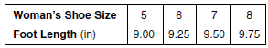

- The linear correlation coefficient for this relationship is
1) | 1 | 2) |  | 3) | 0.5 | 4) | 0

- Write the equation of the linear function.

