Name: Period: Job 23 Adding and Subtracting Polynomials

Part 1: Textbook
Textbook Lesson 7-1 Page 265-266: 28, 32, 33, 34, 36, 39
Part 2: Algebra Regents Questions –

- If $A=3x^{2}+5x-6$ and $B=-2x^{2}-6x+7$, then $A-B$ equals

(1) $-5x^{2}-11x+13$ (3) $-5x^{2}-x+1$
(2) $5x^{2}+11x-13$ (4) $5x^{2}-x+1$

- Subtract $5x^{2}+2x-11$ from $3x^{2}+8x-7$. Express the result as a trinomial.

- To watch a varsity soccer game, spectators must buy a ticket at the door. The cost of an adult ticket is $3.50 and the cost of a student ticket is $2.00. If the number of adult tickets sold is represented by a and students tickets sold by s, which expression represents the amount of money collected at the door from ticket sales?

(1) $5.50as$ (3) $5.50(a+s)$

(2) $(3.50a)(2.00s)$ (4) $3.50a+2.00s$

- When multiplying polynomials for a math assignment, pat found the product to be $-4x+{8x}^{2}-2x^{3}+5$ . He then had to state the leading coefficient of this polynomial. Pat wrote down $-4$. Do you agree with Pat’s answer? Explain your reasoning.

- Camille has a video game card worth $185. After she plays the first game, the card’s value is $182.25. After she plays the second game, its value is $179.50. After she plays the third game, the card is worth $176.75.

Assuming the pattern continues, write an equation to define A(n), the amount of money on the video game card after n rentals.

Camille plays a game every Friday night. How many weeks in a row can she afford to play a game using her game card only? Explain how you arrived at your answer.

- The graph below models the cost of renting video games with a membership in Plan A and Plan B.
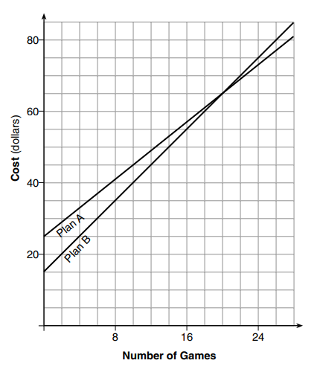
Explain why Plan B is the better choice for Artemio if he only has $40 to spend on video games, including a membership fee.

Josh wants to spend $65 on video games, including a membership fee. Which plan should he choose? Explain your answer.

