Name: Period: Job 33: Lesson 9.1 Solving Quad Graphing
Part 1: Lesson 9-1 Textbook
Page 360: 5, 6, 7, 8, 9, 10, 18, 19
Part 2: Algebra Regents Questions –
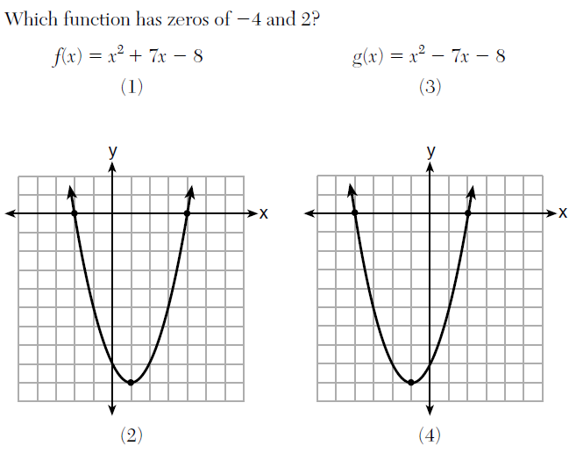

- Solve the inequality below:
$$1.8-0.4y≥2.2-2y$$

- What is the domain of the relation shown below?

$$\left\{\left(4,2\right), \left(1,1\right), \left(0,0\right), \left(1,-1\right), (4,-2)\right\}$$

- $\left\{0,1,4\right\}$ (3) $\left\{-2,-1,0,1,2,4\right\}$
- $\left\{-2,-1,0,1,2\right\}$ (4) $\left\{-2,-1,0,0,1,1,1,2,4,4\right\}$

- Jakob is working on his math homework. He decided that the sum of the expression $\frac{1}{3}+\frac{6\sqrt{5}}{7}$ must be rational because it is a fraction. Is Jakob correct? Explain your reasoning.

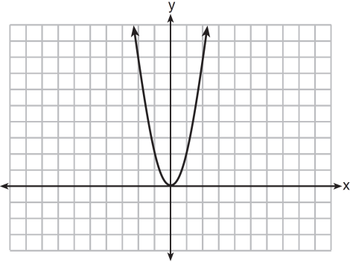
- The graph of the equation $y=ax^{2}$ is shown.
If a is multiplied by $–\frac{1}{3}$ , the graph of the new equation is
1) | wider and opens downward
2) | wider and opens upward
3) | narrower and opens downward
4) | narrower and opens upward
- Determine and state whether the sequence $1, 3, 9, 27, …$ displays exponential behavior. Explain how you arrived at your decision.

7. How many real solutions does the equation $x^{2}-2x+5=0$ have? Justify your answer.

8. Given the function $f\left(x\right)=-x^{2}+8x+9$, rewrite$f(x)$ in vertex form

9. Subtract $-4x^{2}+3x-11$ from $3x^{2}+8x-7$. Express the result as a trinomial.

