Name: Period: Job 35: Solving Quadratics Using Square Roots
Part 1: Lesson 9-2 & 9-4 Textbook
Lesson 9-3 Page 367: 6, 8, 10, 29
Lesson 9-4 Page 379: 6, 9, 10, 14, 15

Part 2: Algebra Regents Questions –

- Ramier determines the zeros of the function $f(x)$ to be $-9$ and $3$. What could be Ramier’s function?

(1) $f\left(x\right)=(x+9)(x+3)$ (3) $f\left(x\right)=(x+9)(x-3)$
(2) $f\left(x\right)=(x-9)(x+3)$ (4) $f\left(x\right)=(x-9)(x-3)$

2. The function $g\left(t\right)={-8t}^{2}+72$ represents the height, $g(t)$, in feet of an object from the ground at $t$ seconds after it is dropped. A realistic domain for this function is

(1) $-3≤t≤3$ (3) $0≤g(t)≤72$

(2) $0≤t≤3$ (4) all real numbers

- A company produces $x$ units of a product per month, where $C(x)$ represents the total cost and $R(x)$ represents the total revenue for the month. The functions are modeled by $C\left(x\right)=300x+250$ and $R\left(x\right)=-0.5x^{2}+800x-100$. The profit is the difference between revenue and cost where $P\left(x\right)=R\left(x\right)-C(x)$. What is the total profit, $P\left(x\right)=R\left(x\right)-C(x)$. What is the total profit, $P(x)$, for the month?

- $P\left(x\right)=-0.5x^{2}+500x-150$
- $P\left(x\right)=-0.5x^{2}+500x-350$
- $P\left(x\right)=-0.5x^{2}-500x+350$
- $P\left(x\right)=-0.5x^{2}+500x+350$

- The third term in an arithmetic sequence is 10 and the fifth term is 26. If the first term is $a_{1}$, which is an equation for the $n$th term of this sequence?
- $a_{n}=8n+10$ (3) $a_{n}=16n+10$
- $a_{n}=8n-14$ (4) $a_{n}=16n-38$

- Which expression is equivalent to $x^{4}-12x^{2}+36$?
- $(x^{2}-6)(x^{2}-6)$ (3) $(6-x^{2})(6+x^{2})$
- $(x^{2}+6)(x^{2}+6)$ (4) $(x^{2}+6)(x^{2}-6)$

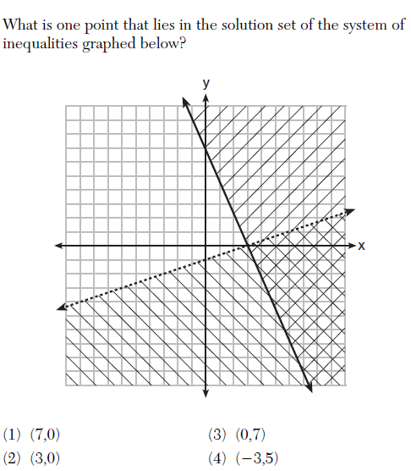

- Which situation could be modeled by using a linear function?
- A bank account balance that grows at a rate of 5% per year, compounded annually
- A population of bacteria hat doubles every 4.5 hours
- The cost of a cell phone service that charges a base amount plus 20 cents per minute
- The concentration of medicine in a person’s body that decays by a factor of one-third every hour

