Name: Period: Job 36: Solving Quad by Completing the Square
Part 1: Lesson 9-5 Textbook
Page 386: 6, 8, 10, 12, 14, 29, 32, 36
Part 2: Algebra Regents Questions –

1.
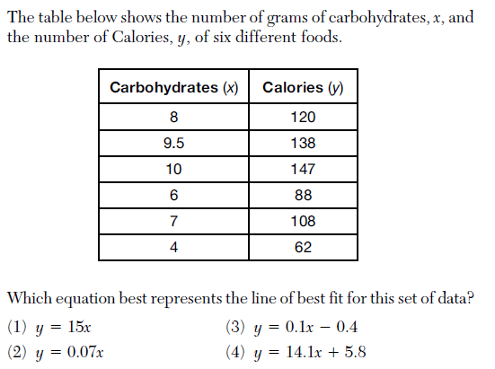

2.

3.

4.
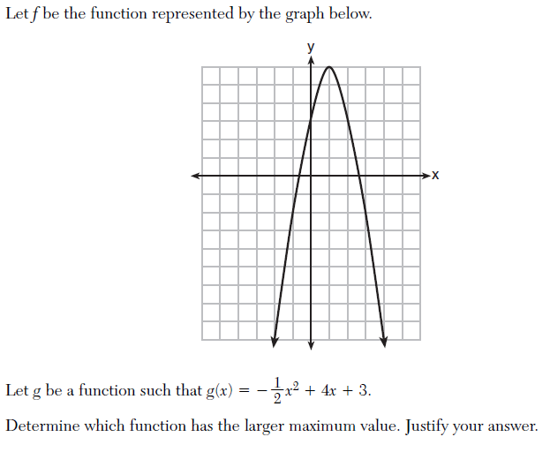

5.
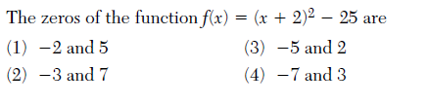
6.

7.
