Name: Period: Job 37: Solving Quadratic w Quadratic Formula .
Part 1: Lesson 9-6 Textbook
Page 393: 15, 19, 21, 23, 30, 31

Part 2: Algebra Regents Questions –

- Which equation has the same solutions as $x^{2}-6x-12=0$?

- ${(x+3)}^{2}=21$ (3) ${(x+3)}^{2}=3$
- ${(x-3)}^{2}=21$ (4) ${(x-3)}^{2}=3$

- A student was given the equation $x^{2}+6x-13=0$ to solve by completing the square. The first step that was written is shown below.
$$x^{2}+6x=13$$

The next step in the student’s process was $x^{2}+6x+c=13+c$.

State the value of $c$ that creates the perfect square trinomial.

Explain how $c$ is determined.

- What are the roots of the equation $x^{2}+4x-16=0$?
- $2±2\sqrt{5}$ (3) $2±4\sqrt{5}$
- $-2±2\sqrt{5}$ (4) $-2±4\sqrt{5}$

- Keith determines the zeros of the function $f(x)$ to be $-6$ and $5$. What could be Keith’s function?
- $f\left(x\right)=(x+5)(x+6)$ (3) $f\left(x\right)=(x-5)(x+6)$
- $f\left(x\right)=(x+5)(x-6)$ (4) $f\left(x\right)=(x-5)(x-6)$

- On the axes below, graph $f\left(x\right)=|3x|$.
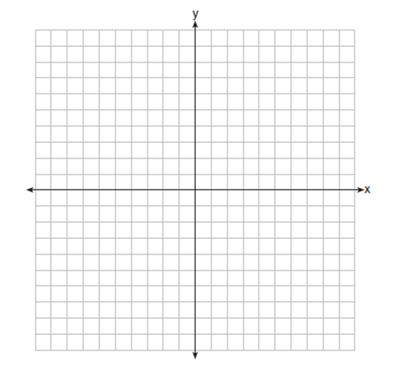
If $g\left(x\right)=f\left(x\right)-2$, how is the graph of $f(x)$ translated to the graph of $g(x)$?

If $h\left(x\right)=f(x-4)$, how is the graph of $f(x)$ translated to the graph of $h(x)$?

- Determine and state whether the sequence $1, 3, 9, 27, …$ displays exponential behavior. Explain how you arrived at your decision.

- Solve for $x$: ${(x+2)}^{2}=10$. State if the solution is rational or irrational and why.

- Given $2x+ax-7>-12$, determine the largest integer value of $a$ when $x=-1$/

