Name: Period: Job 38: Solving Linear – Quad Systems
Part 1: Lesson 9-7 Textbook
Page 400: 9, 11, 24, 25, 28
Part 2: Algebra Regents Questions –

- The zeros of the function $f\left(x\right)={3x}^{2}-3x-6$ are
- $-1$ and $2$ (3) $1$ and $2$
- $1$ and $-2$ (4) $-1$ and $2$

- Each day Toni records the height of a plant for her science lab. Her data are shown in the table below.
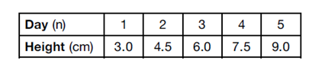
The plant continues to grow at a constant daily rate. Write an equation to represent $h(n)$, the height of the plant on the $n$th day.

- The table below shows the year and the number of households in a building that had high-speed broadband internet access.
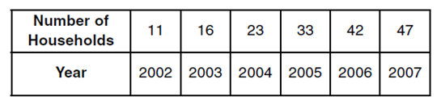
For which interval of time was the average rate of change the smallest?
- $2002-2004$ (3) $2004-2006$
- $2003-2005$ (4) $2005-2007$

- Which polynomial function has zeros at $-3, 0,$and $4$?
- $f\left(x\right)=(x+3)(x^{2}+4)$ (3) $f\left(x\right)=x(x+3)(x-4)$
- $f\left(x\right)=(x^{2}-3)(x-4)$ (4) $f\left(x\right)=x(x-3)(x+4)$

- The number of carbon atoms in a fossil is given by the function $y=5100{(0.95)}^{x}$, where $x$ represents the number of years since being discovered.
What is the percent of change each year? Explain how you arrived at your answer.

- Which trinomial is equivalent to $3{(x-2)}^{2}-2(x-1)$?

- ${3x}^{2}-2x-10$ (3) ${3x}^{2}-14x+10$
- ${3x}^{2}-2x-14$ (4) ${3x}^{2}-14x+14$

- Jackson is starting an exercise program. The first day he will spend 30 minutes on a treadmill. He will increase his time on the treadmill by 2 minutes each day. Write an equation for $T(d)$, the time, in minutes, on the treadmill on day $d$.

- If Lylah completes the square for $f\left(x\right)=x^{2}-12x+7$ in order to find the minimum, she must write $f(x)$ in the general form $f\left(x\right)={(x-a)}^{2}+b$. What is the value of $a$ for $f(x)$?
- $6$ (3) $12$
- $12$ (4) $-12$

8. Subtract ${5x}^{2}+2x-11$ from ${3x}^{2}+8x-7$. Express the result as a trinomial.

